1. Apply below mentioned group polices result screenshot is must (7 Marks)

|  |  |
| --- | --- |
| Organizational Unit | Group Policy |
| IT | deny access to registry & task manager |
| Sales | Deny access to CMD and control panel user  settings |
| HR | Deny access to registry and control panel |
| Domain | Domain password policy is user account should lock after 3 wrong user attempts. After 15 mins user account should be unlocked |

**Step 1 :- Created Ou’s and users in Active directory users and computer**

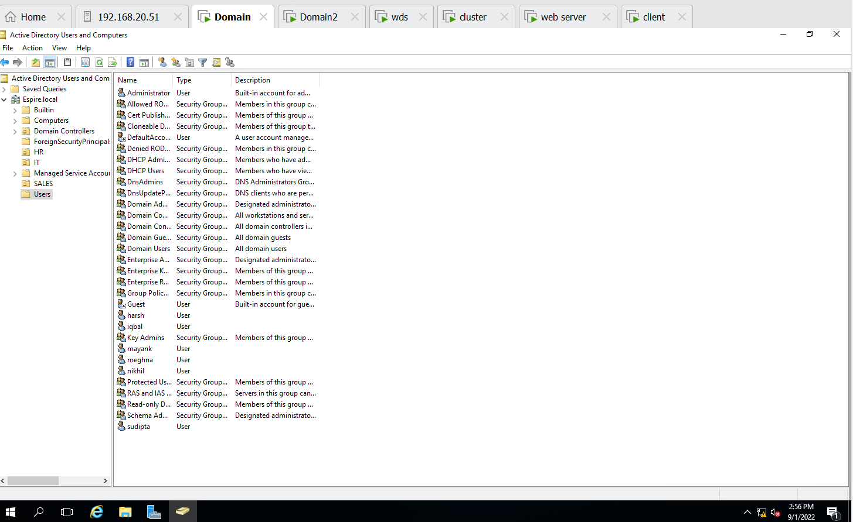

**Step 2 :-- Enabled deny access to task manager**

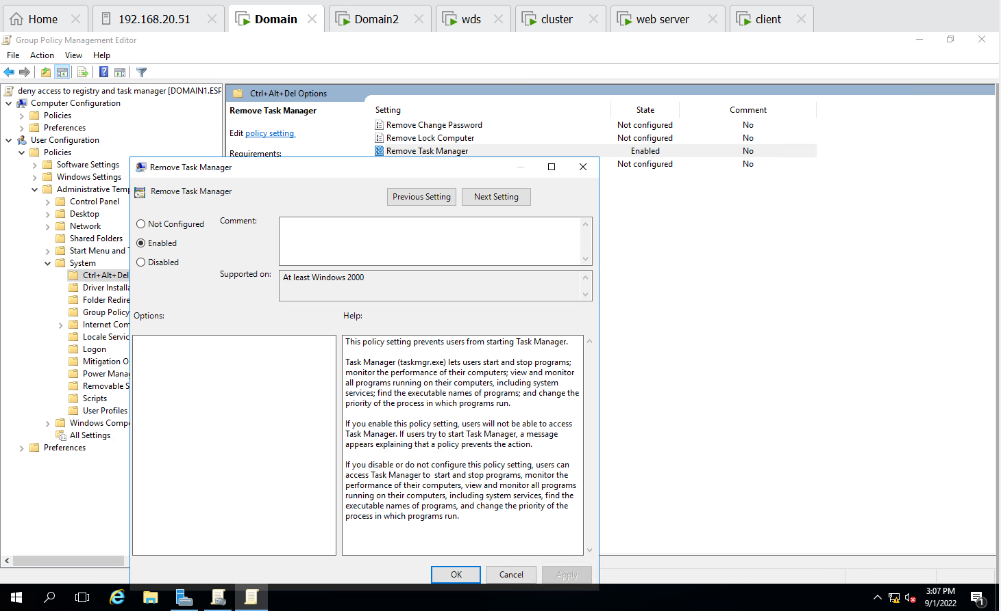

**Step 3 :- Enabled deny access to registry**

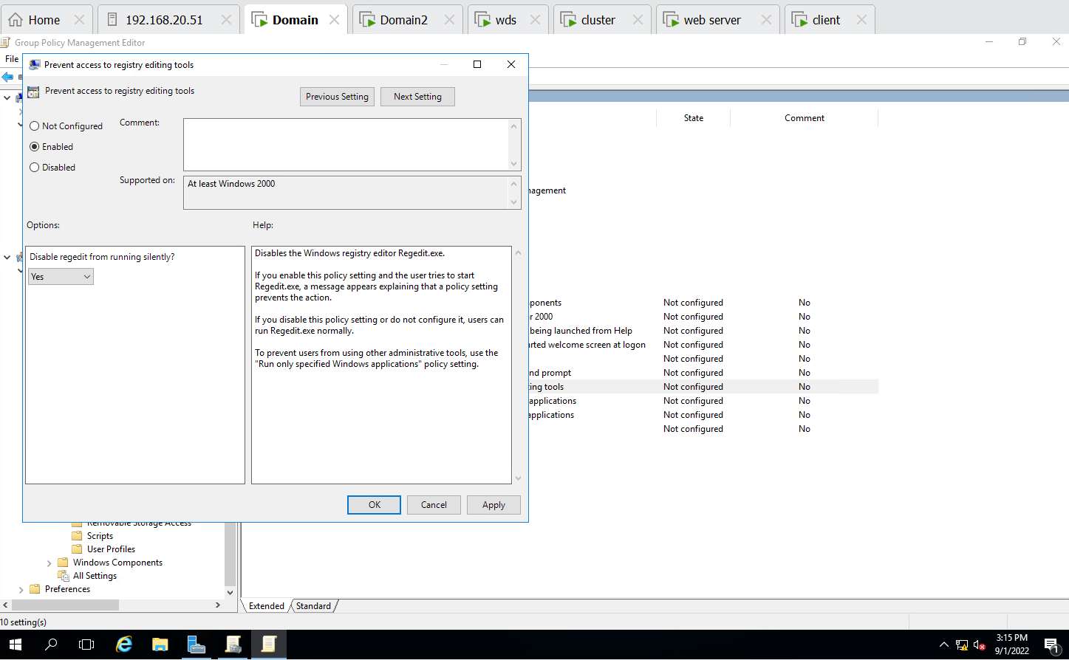

**Step 4 :- Enabled deny access to registry and task manager in IT(OU)**

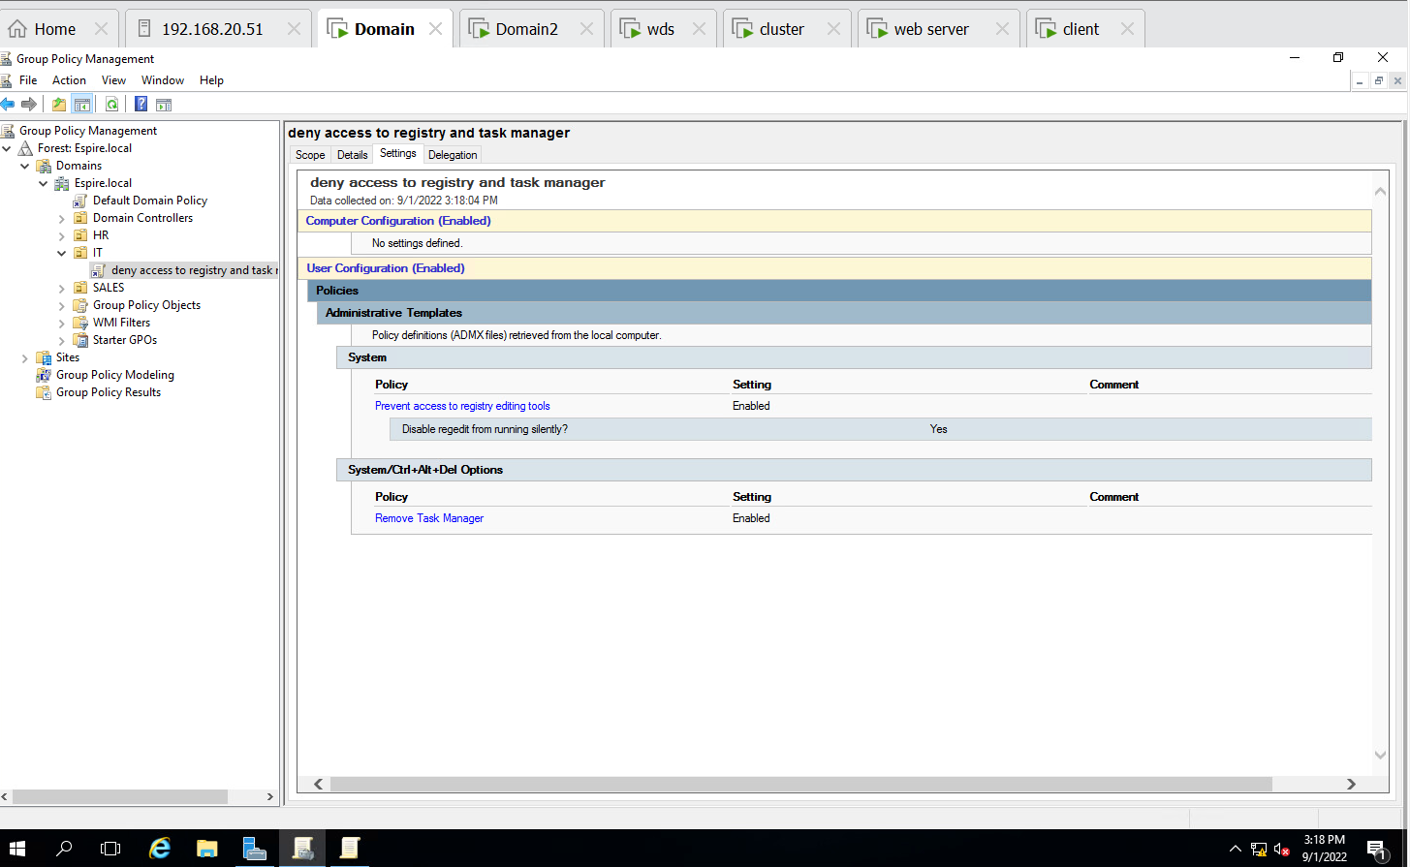

**Step 5:- Successfully enabled deny access to Registry and Manager on IT users(Checked in client machine with IT users)**

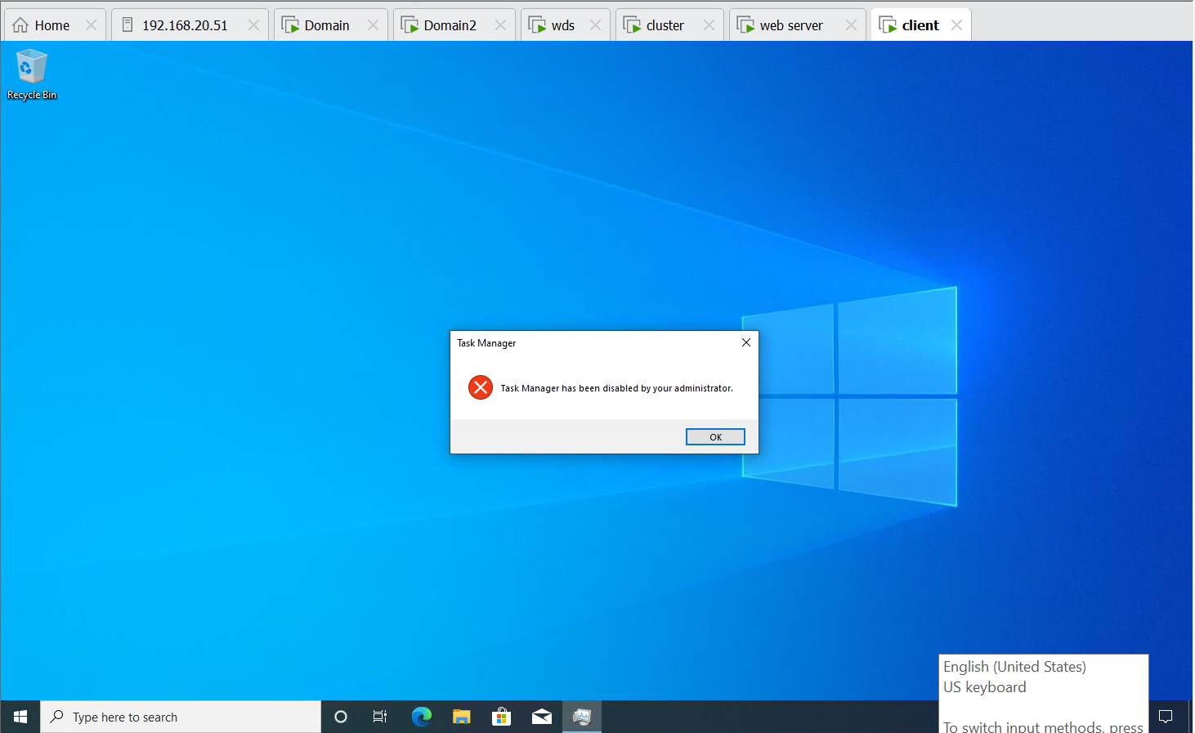

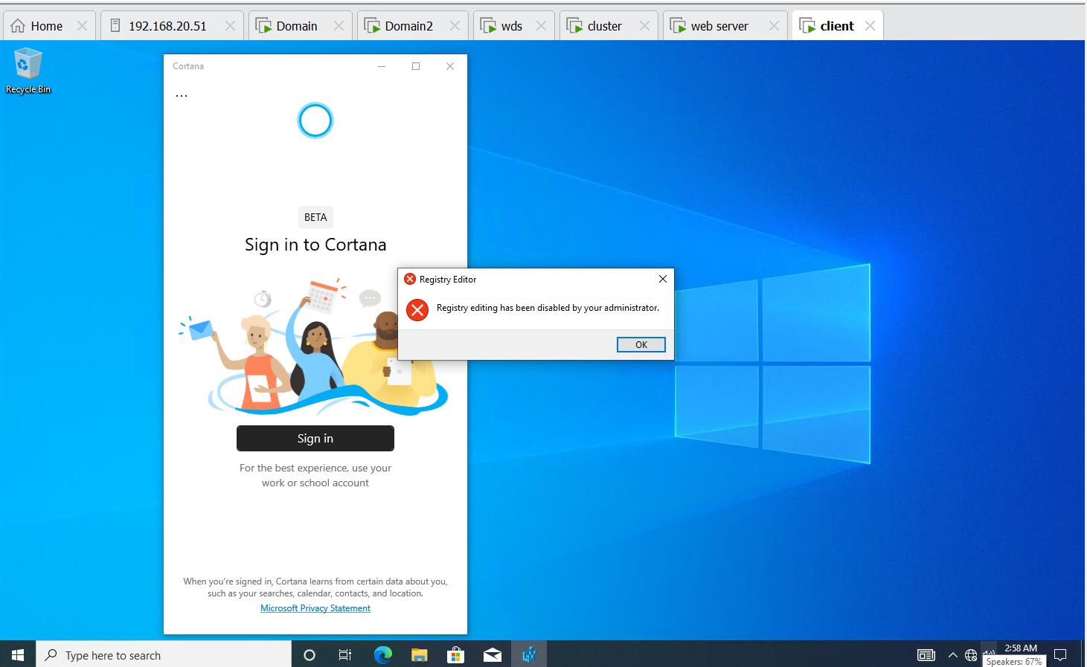

**Step 6 :- Enabled deny access to CMD**

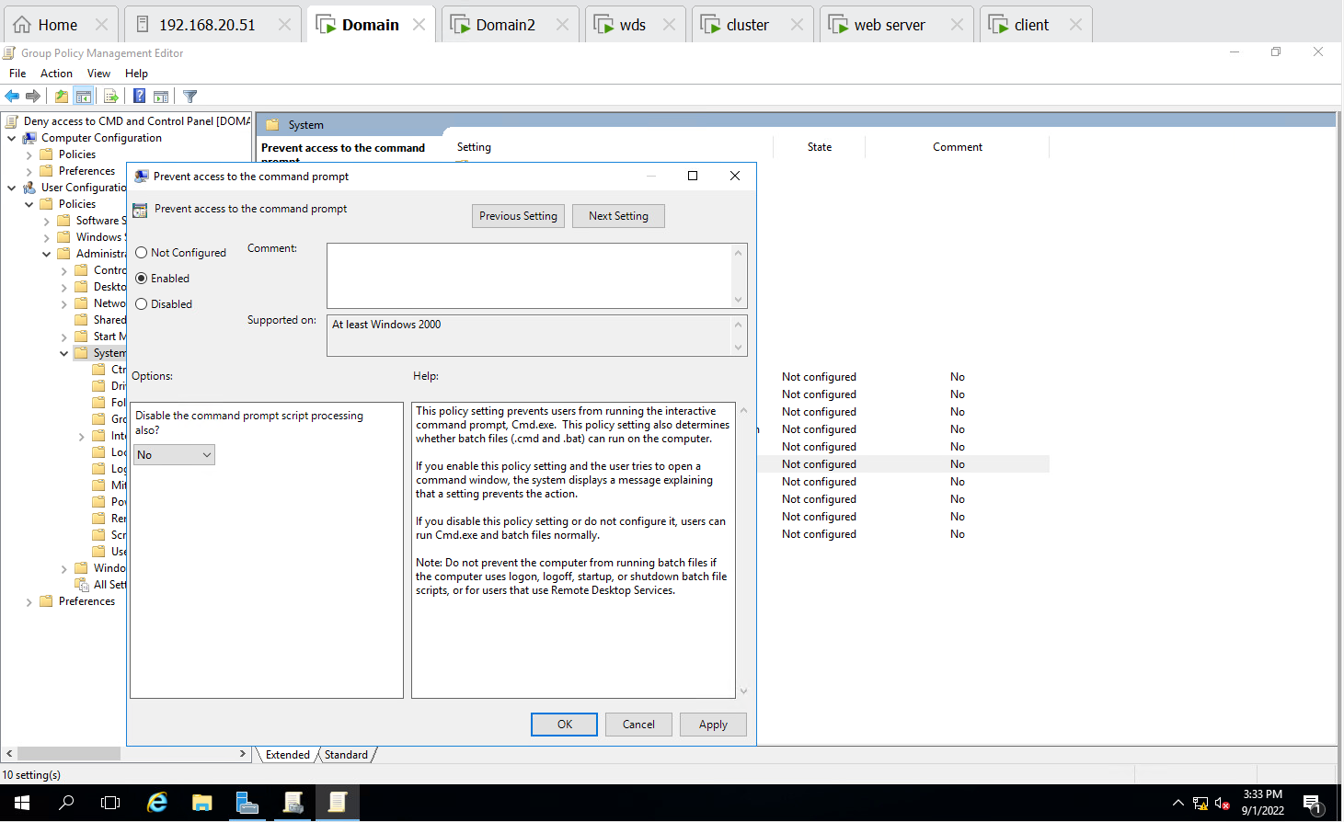

**Step 7:- Enabled Deny access to Control Panel**

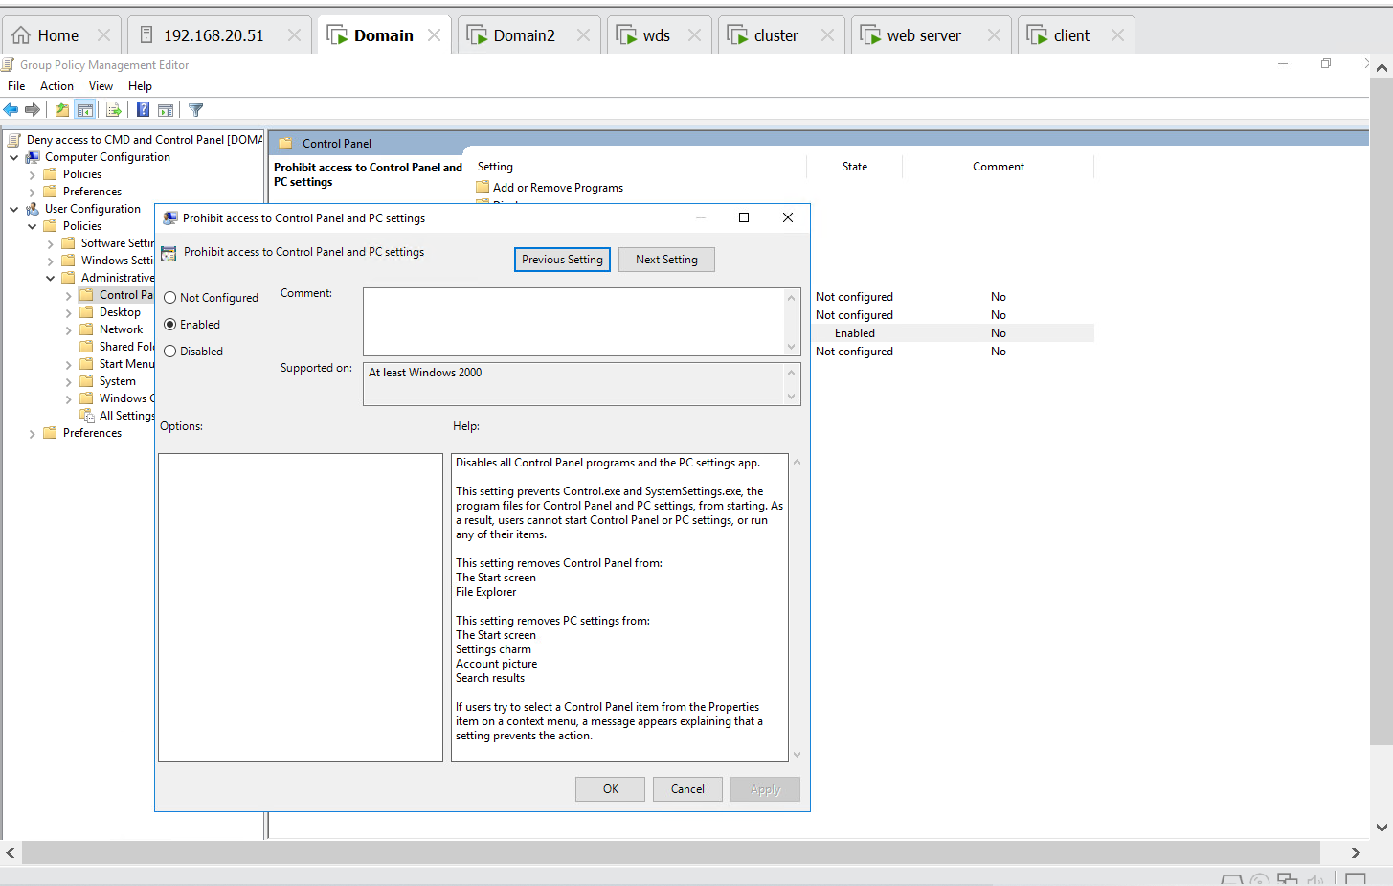

**Step 8 :- Enabled deny access to control panel & CMD in Sales(OU)**

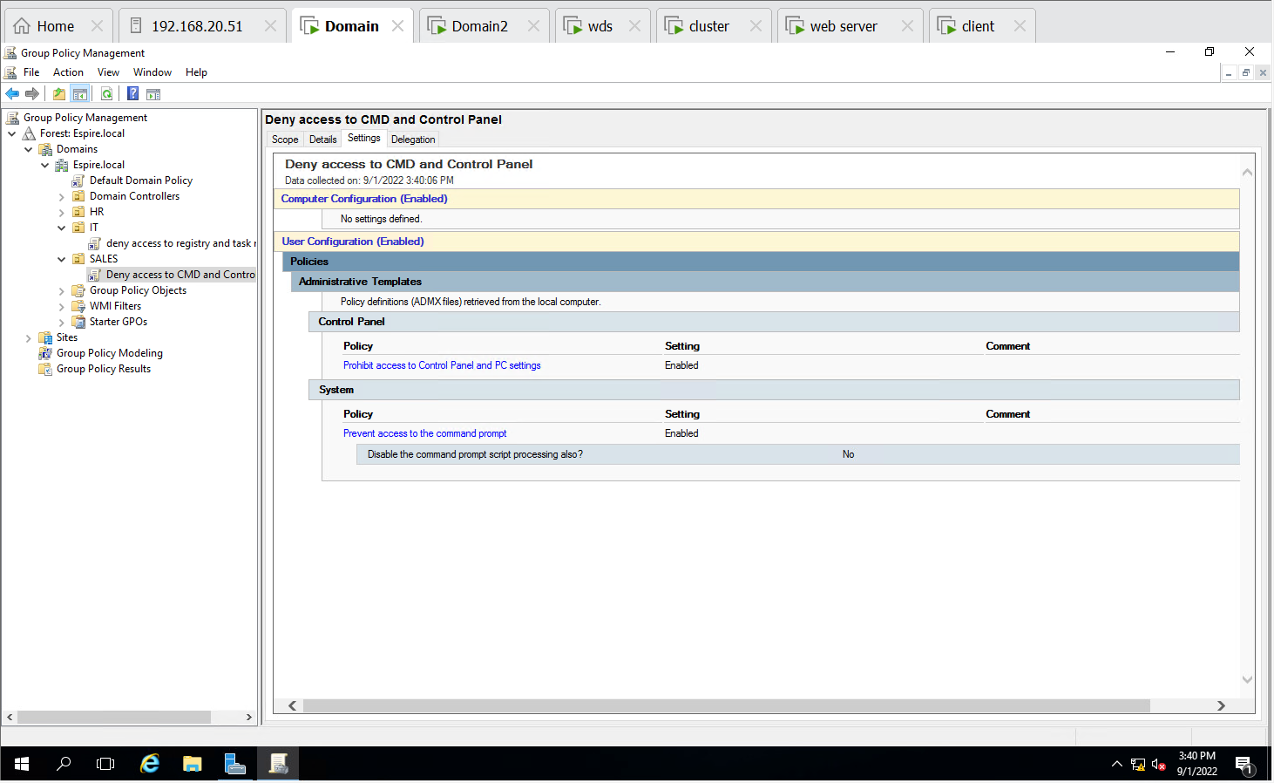

**Step 9 :- Successfully enabled Deny access to CMD & Control Panel and Checked on Client machine with Sales users**

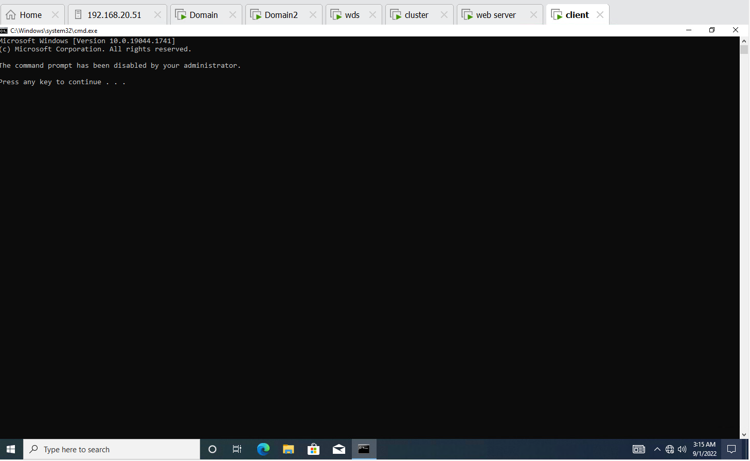

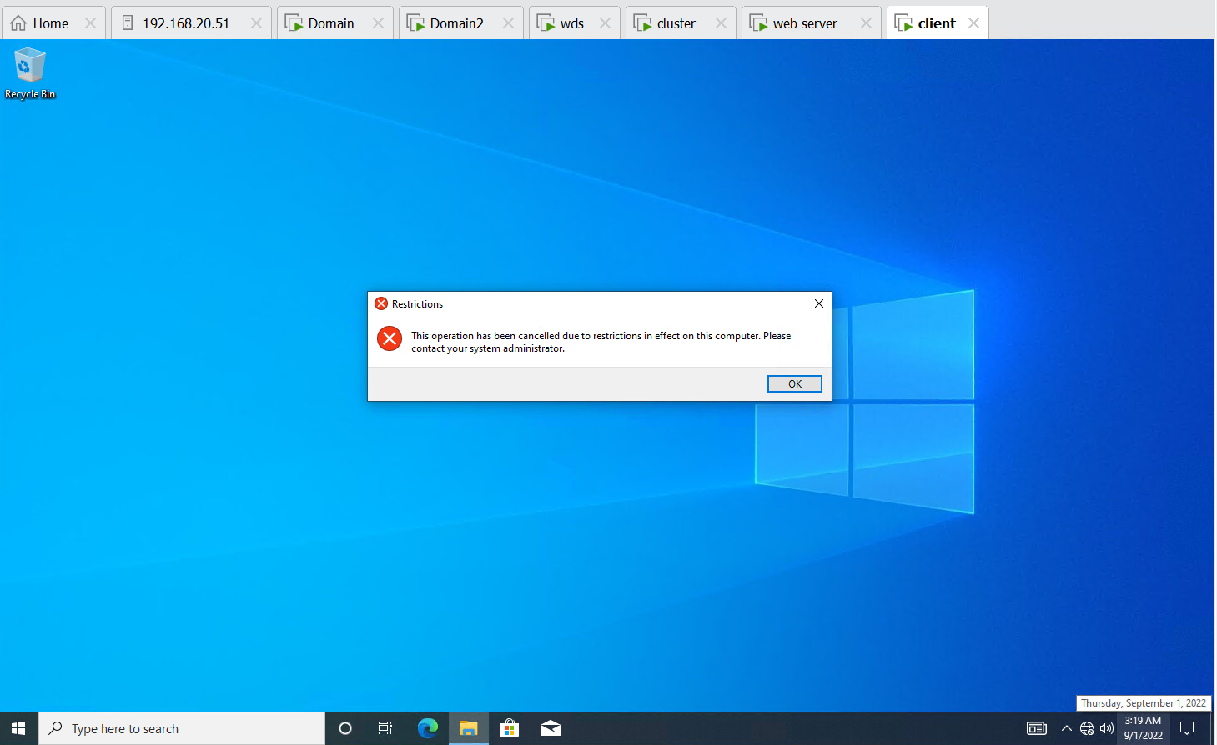

**Step 10 :- Enabled Deny access to registry and control panel in HR**

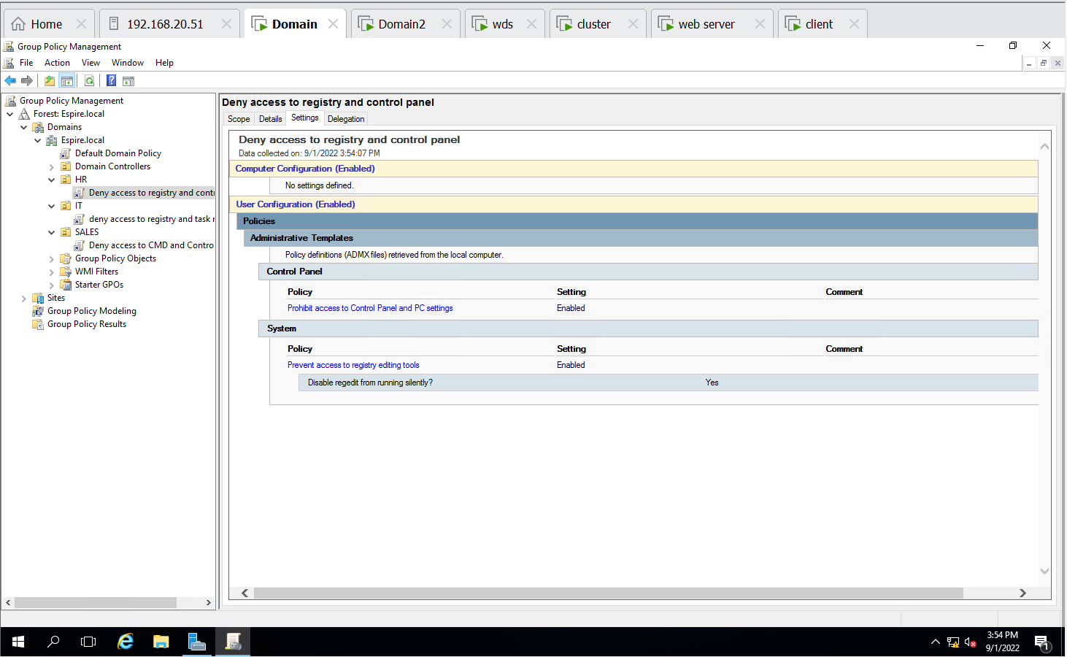

**Step 11 :- Successfully enabled Deny access to Registry & Control Panel and Checked on Client machine with HR users**

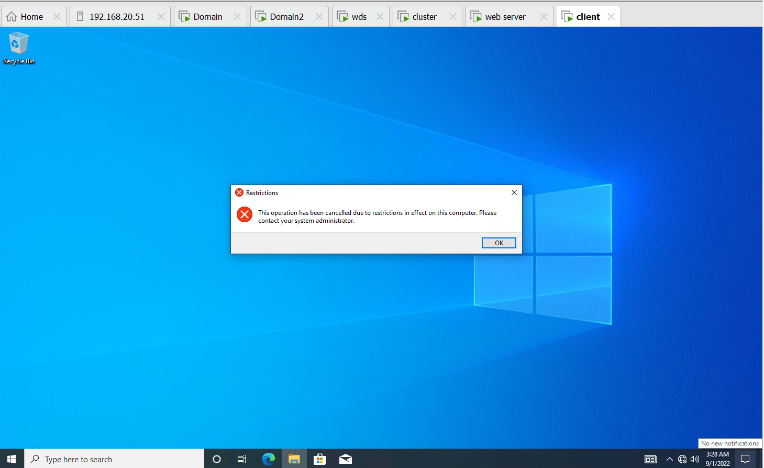

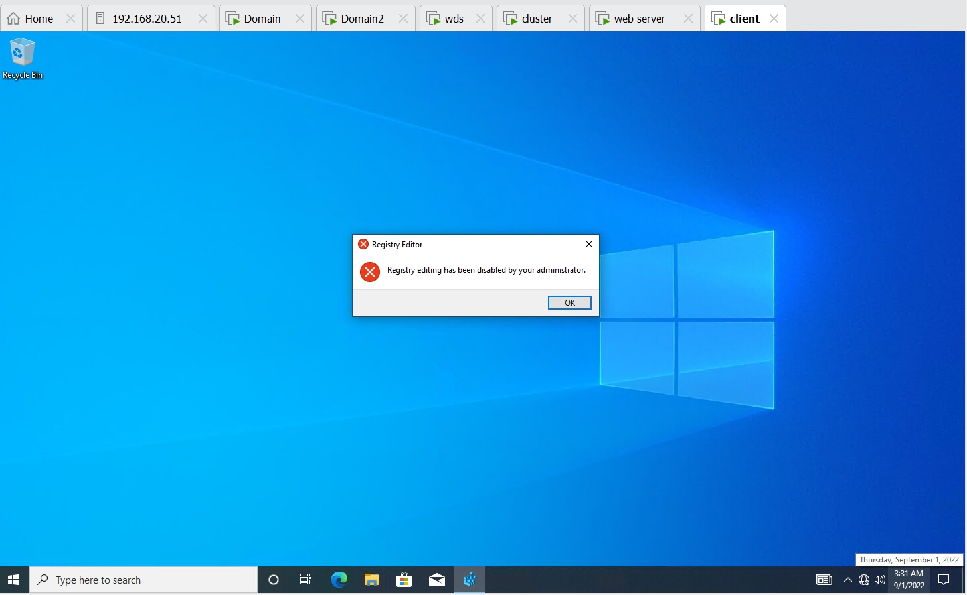

**Step 12 :- Applied Domain password policy is user account should lock after 3 wrong user attempts. After 15 mins user account should be unlocked** 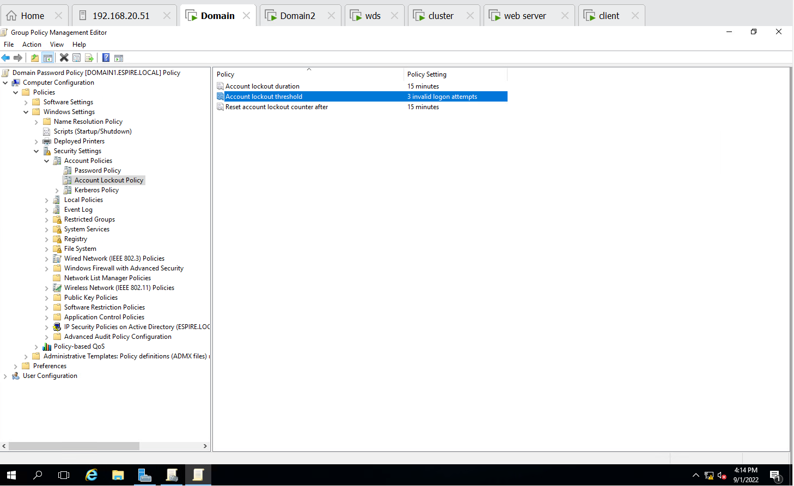

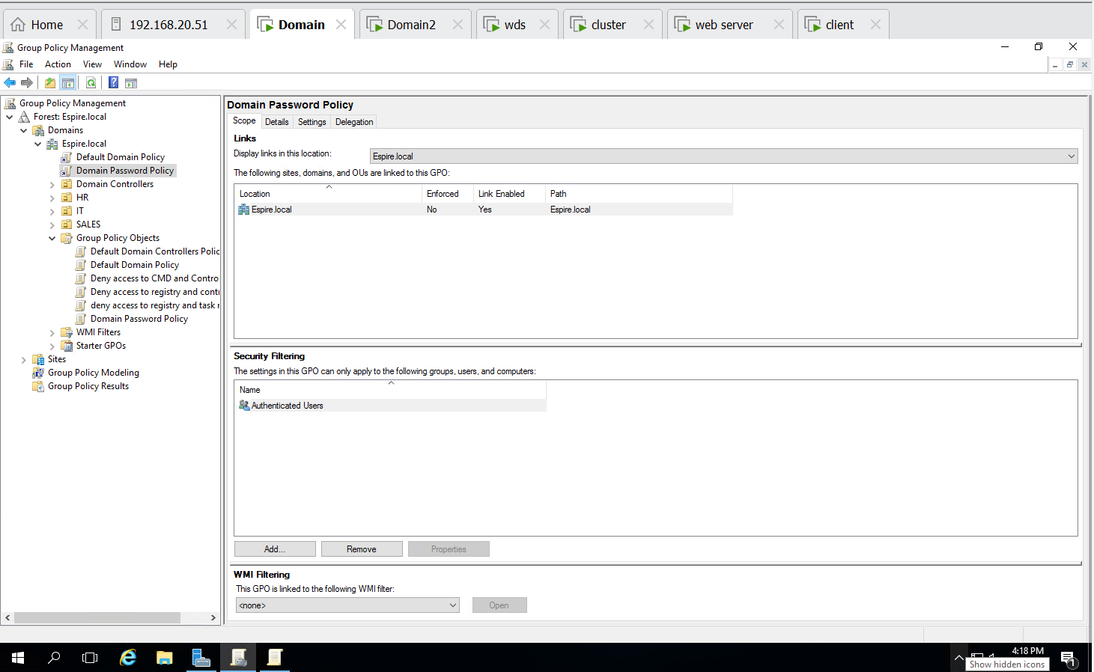

**QUESTION NO. 1 is Completed successfully**

**2.Apply below mentioned configuration using FSRM. Create a folder for IT as mentioned below. Implement and apply the following FSRM Policy. . (5 Marks)**

|  |  |
| --- | --- |
| Folder | FSRM policy |
| IT | 10 MB hard Quota, can’t save  mp4 files |

**Step 1 – Created a new folder name IT in C Drive**

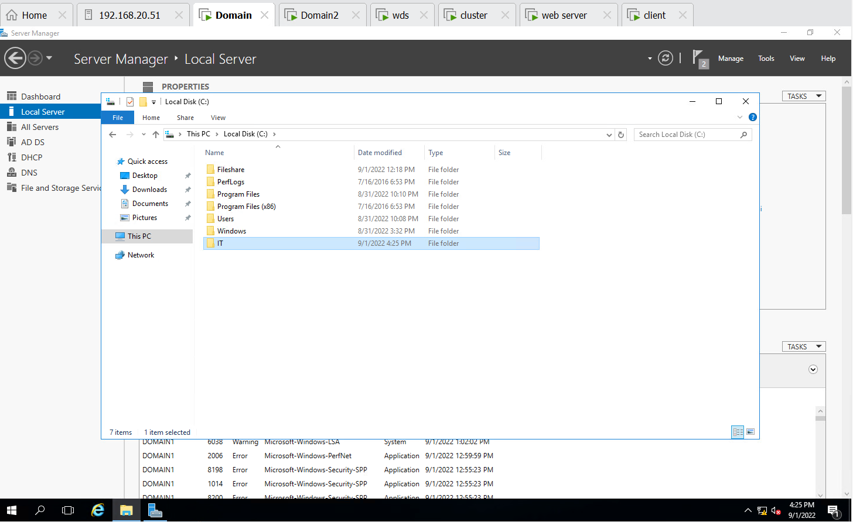

**Step 2:- Created Quota Template & Applied File Screening(Audio & Video) on IT folder in File server resource manager**

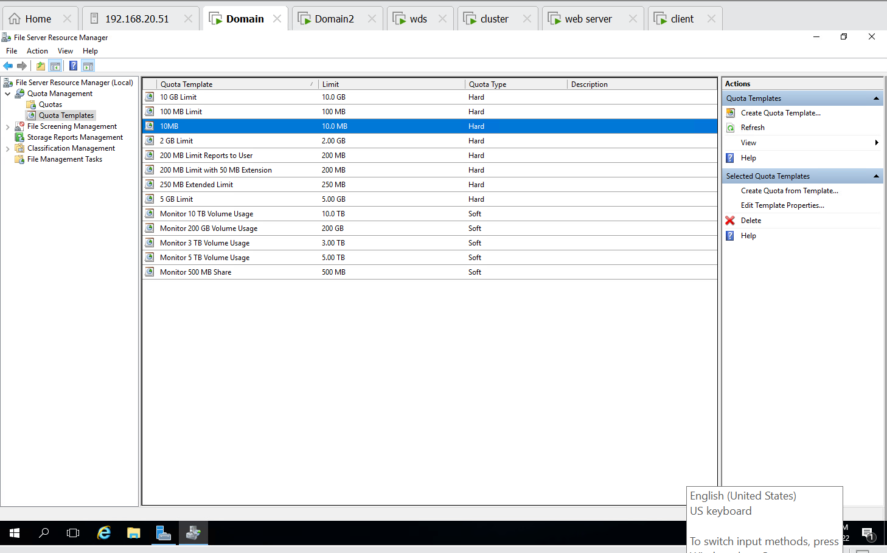

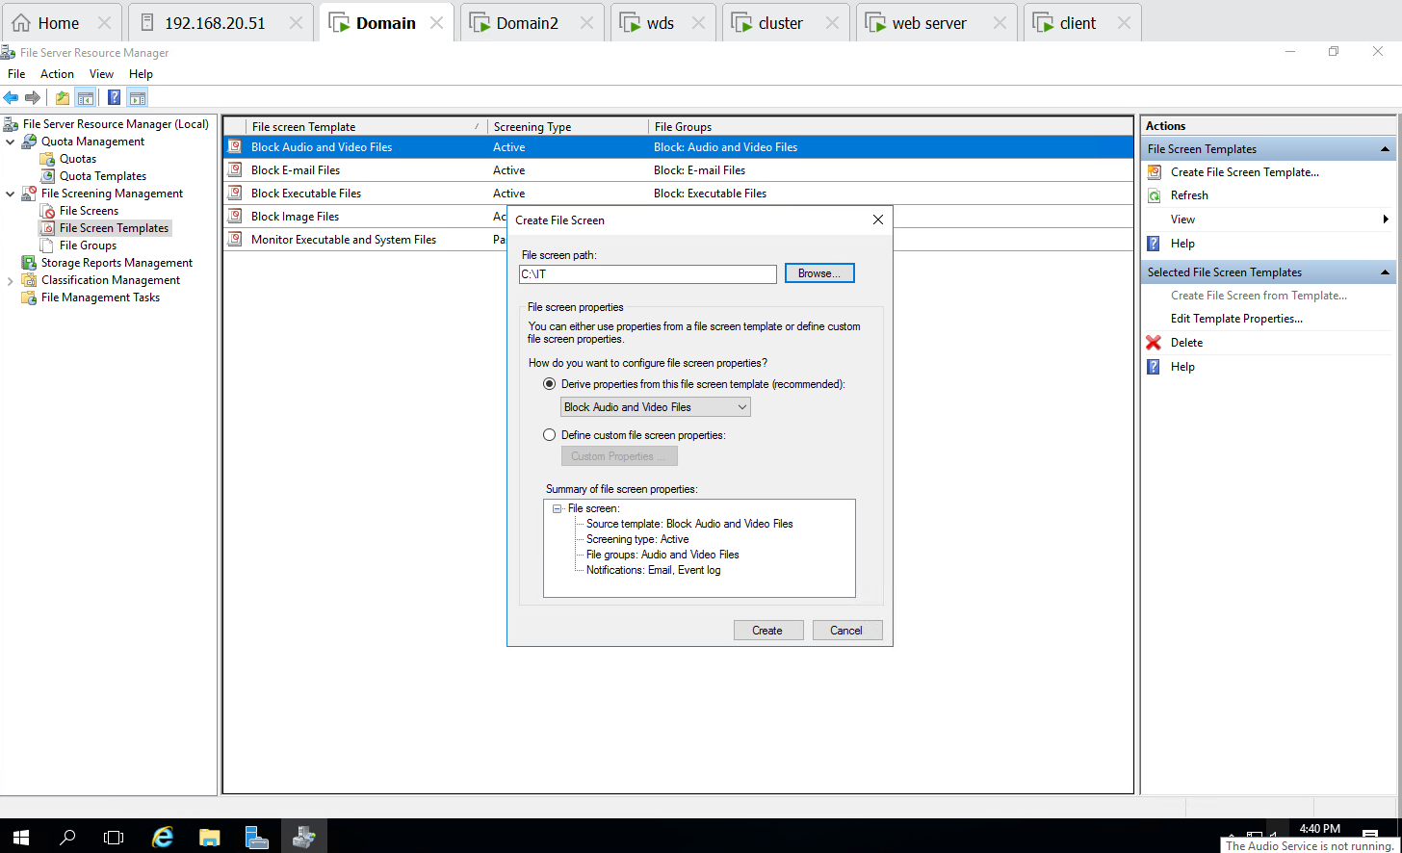

**Step 3 :- Successfully applied file screening templates (Audio & Video) i.e. cant save Mp4 file in IT Folder.**

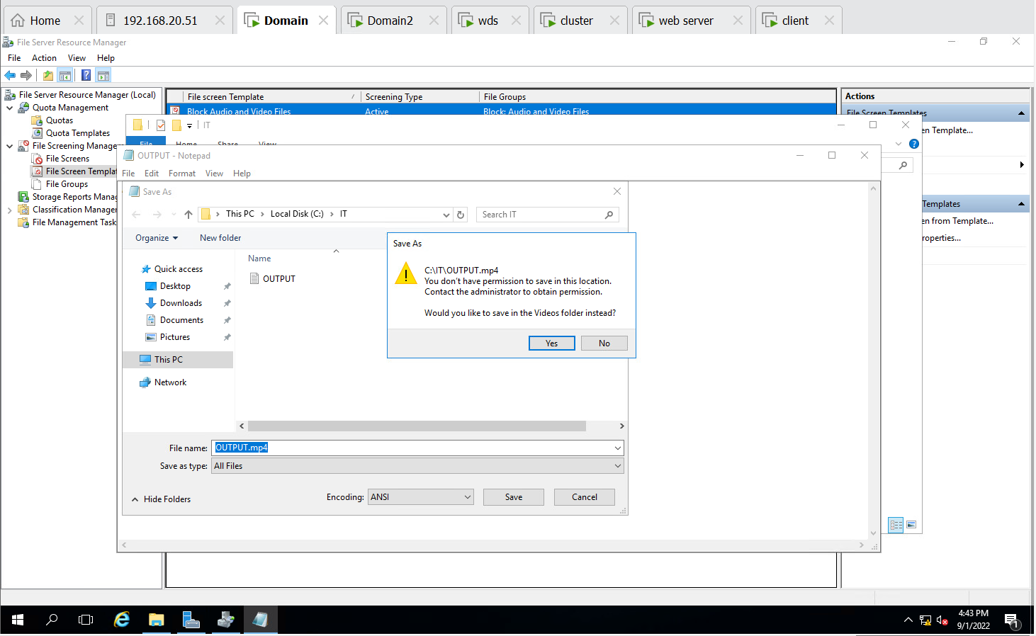

**Step 4:- Created Quota for IT folder with maximum size of 10MB & also Successfully applied on IT folder**

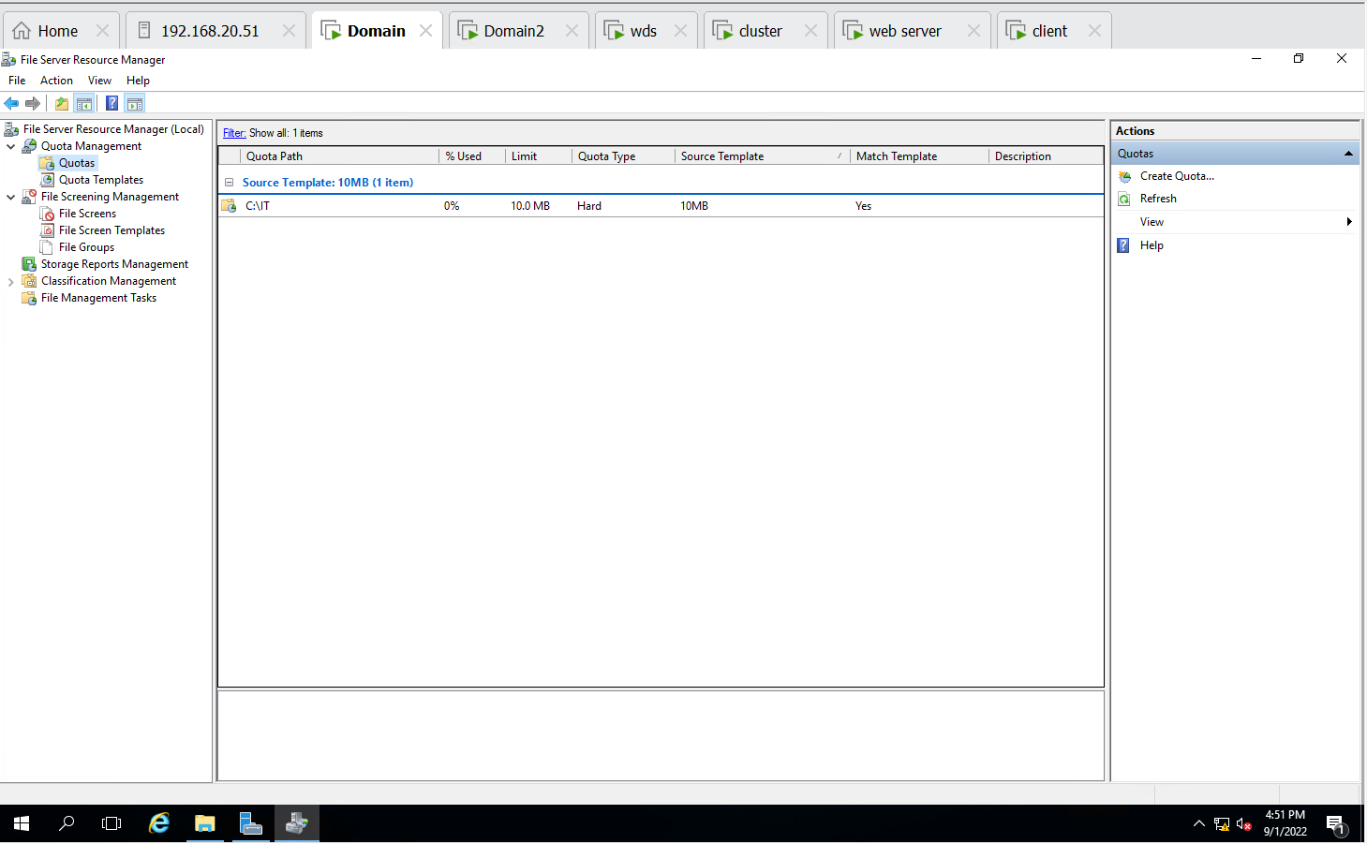

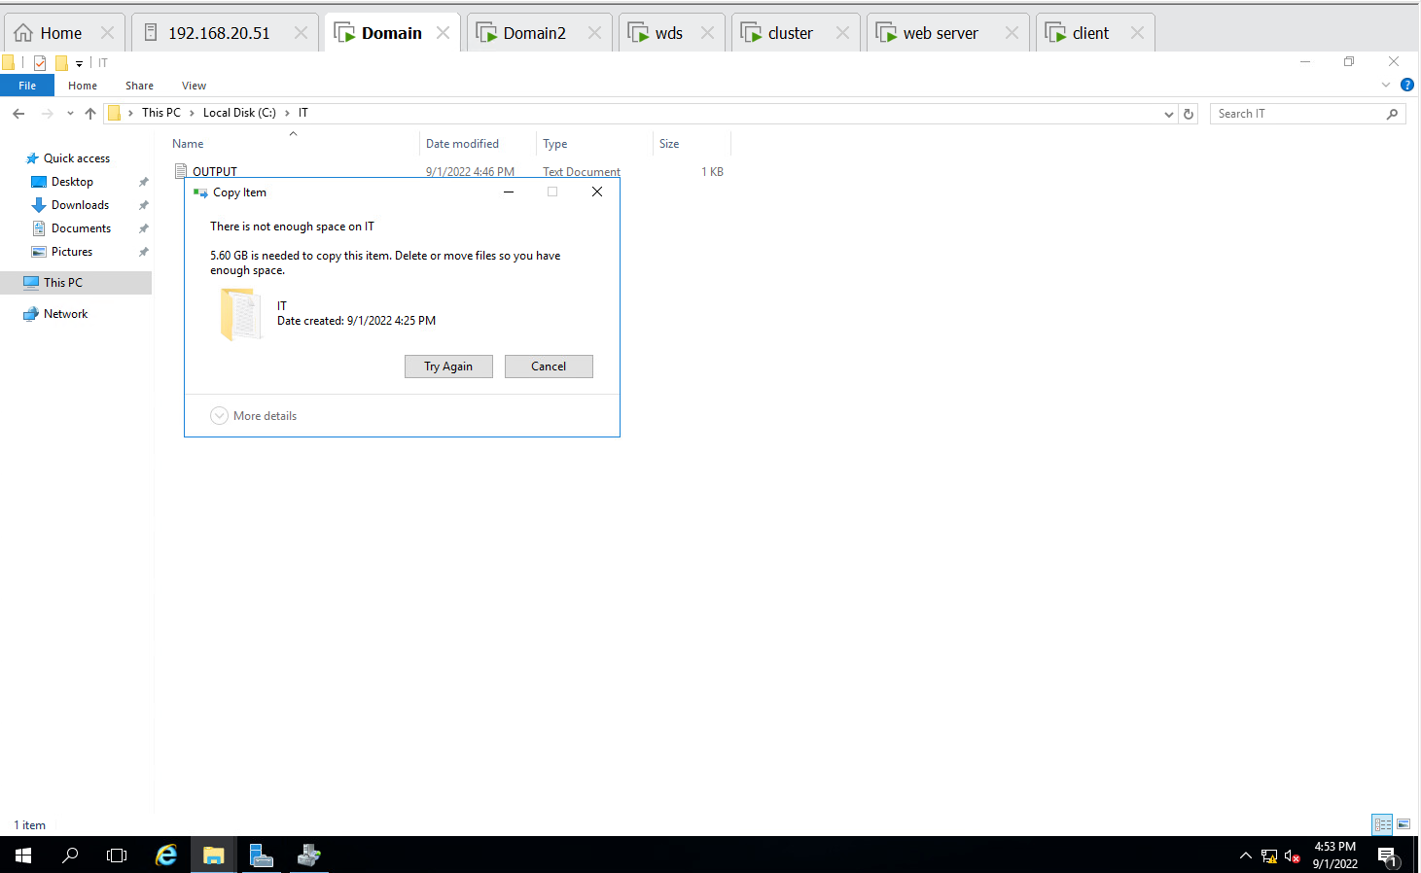

**QUESTION NO. 2 Completed Successfully**

1. Perform Backup of a Server Folder into a shared folder in your Client Machine. Delete your server folder and Recover the folder from that backup

**Step 1 :- Created Backup Schedule once in a day using shared folder in Domain2**

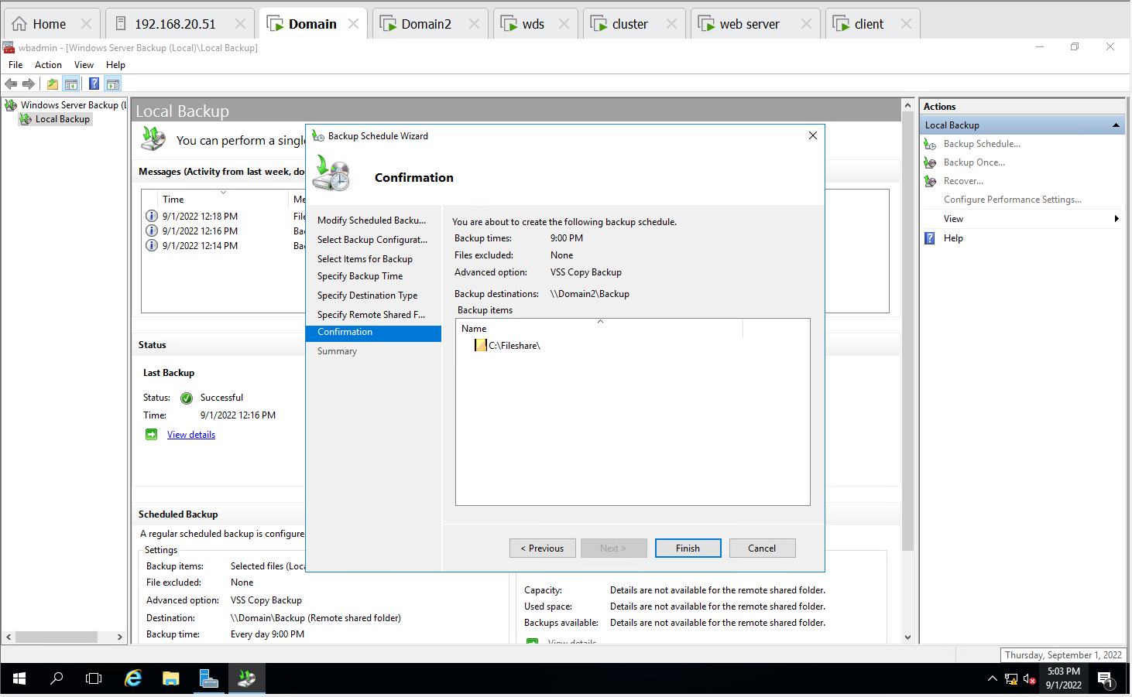

**Step 2:- Created backup once in shared folder i.e. Backup**

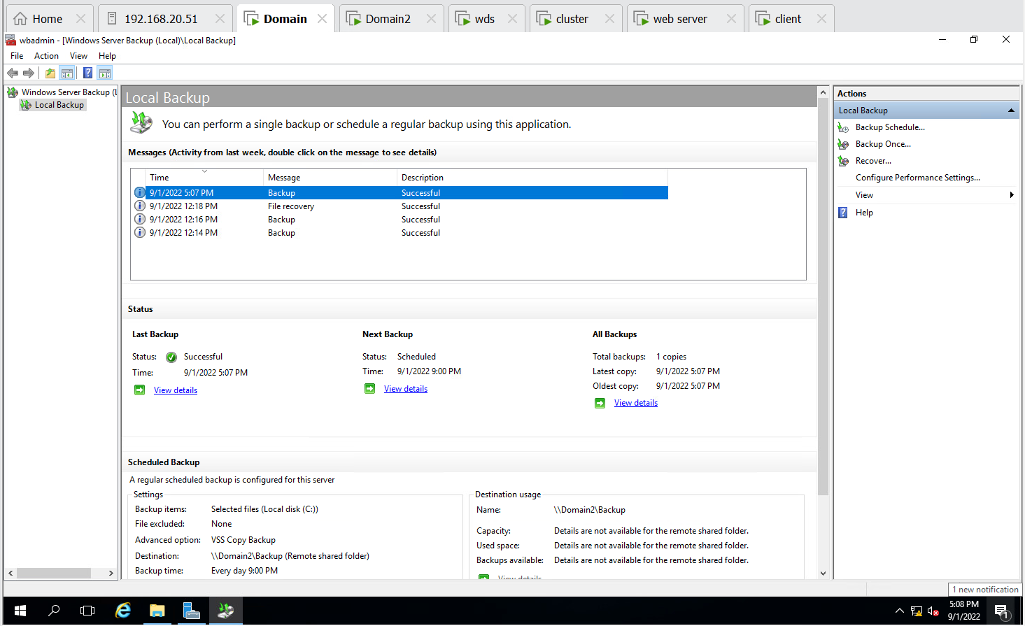

**Step 3:- Deleted files from Fileshare in Domain1**

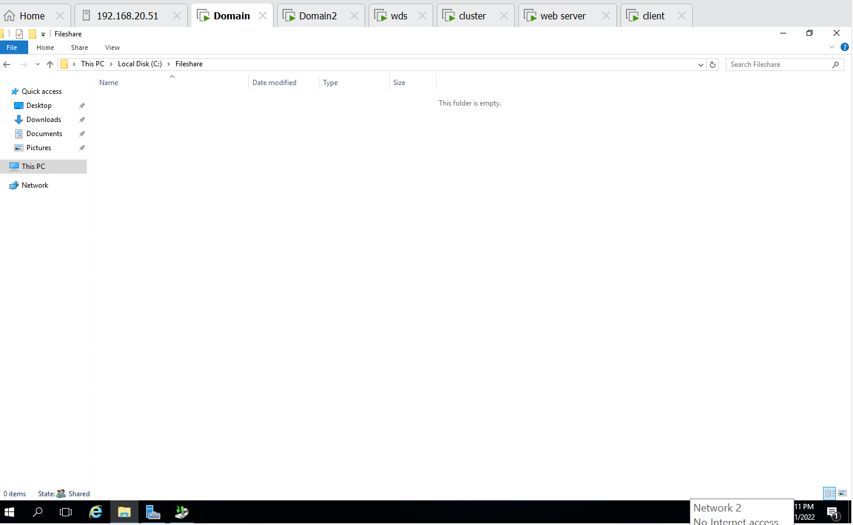

**Step 4:- Selected backup folder and time from Domain 2**

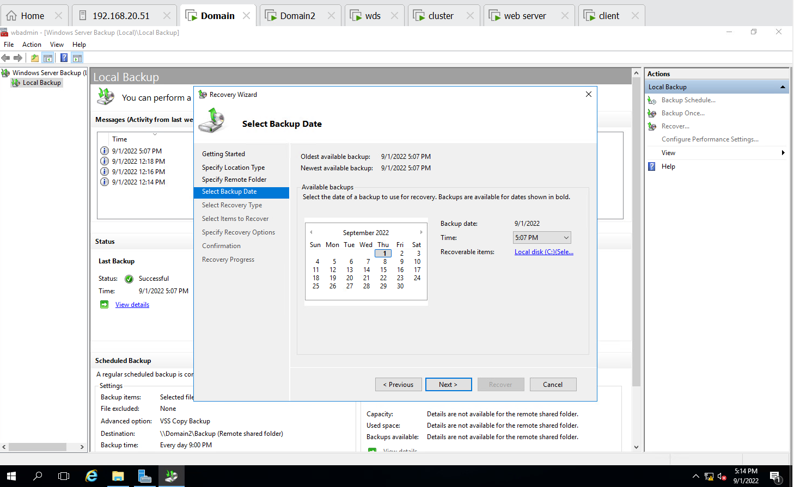

**Step 5 :- Selected item to recovered in Domain1 File share folder**

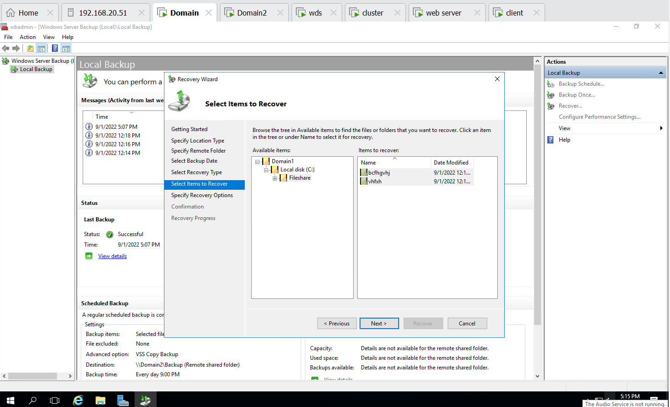

**Step 6 :- Recovered successfully the files from Backup folder to origin folder i.e. File share**

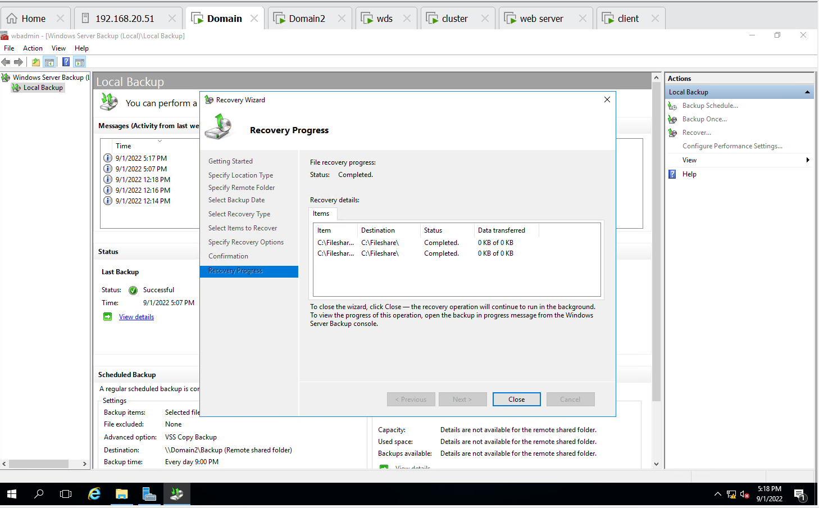

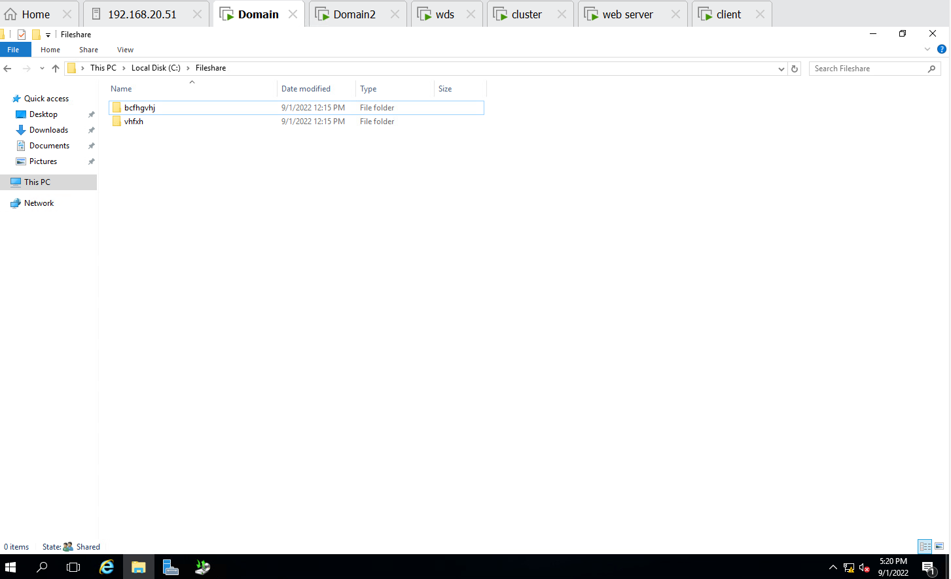

**QUESTION NO. 3 Completed Successfully**

1. Implement network deployment of a Windows 7 OS to clients. Ensure you don’t miss to capture the screenshot of IP address display in the client when loading from WDS. Verify if it is working (Verify if it is reaching to 1% progress of OS installation)

**Step1 :- Selected the path for remote installation folder location**

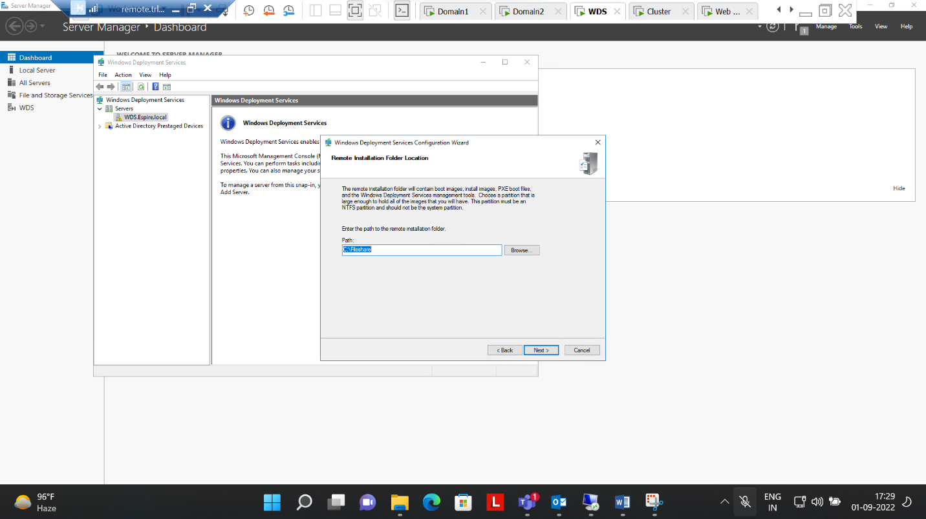

**Step 2:- Boot images and install images added successfully**

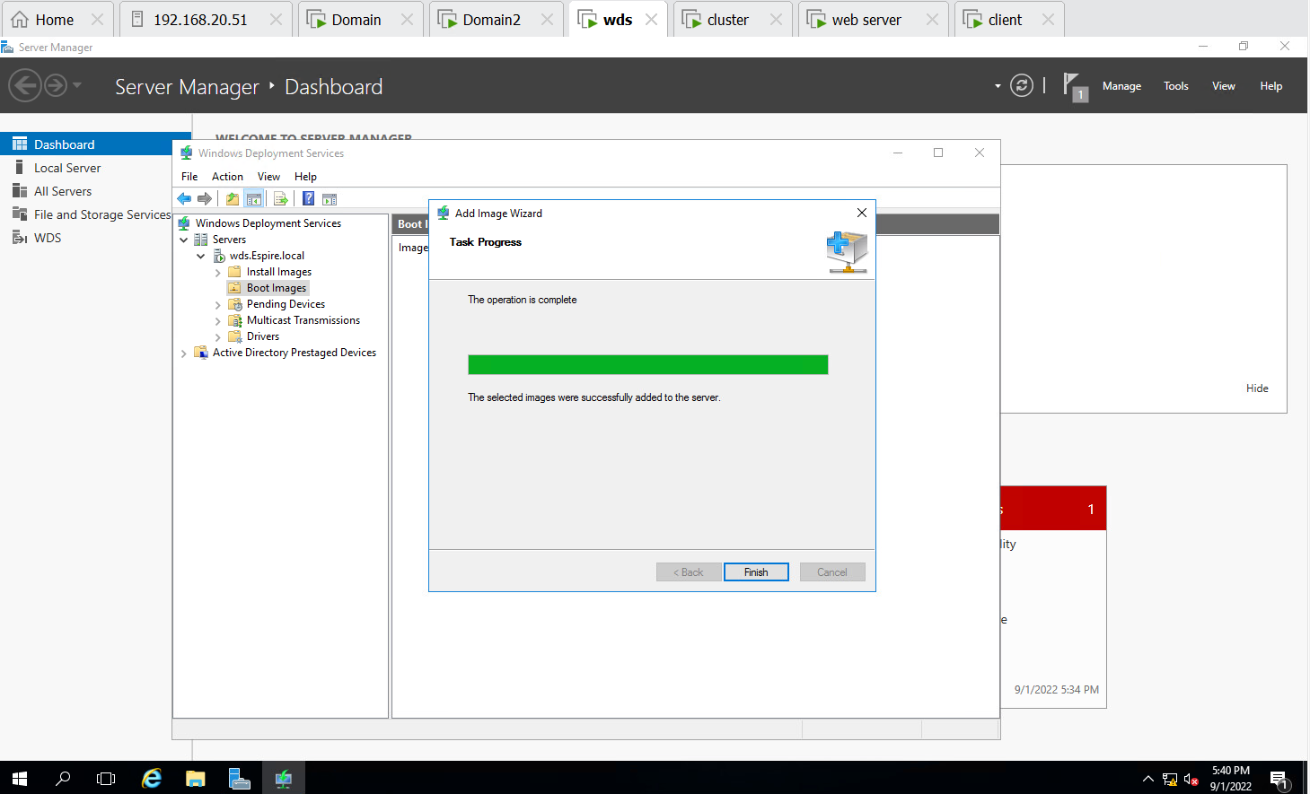

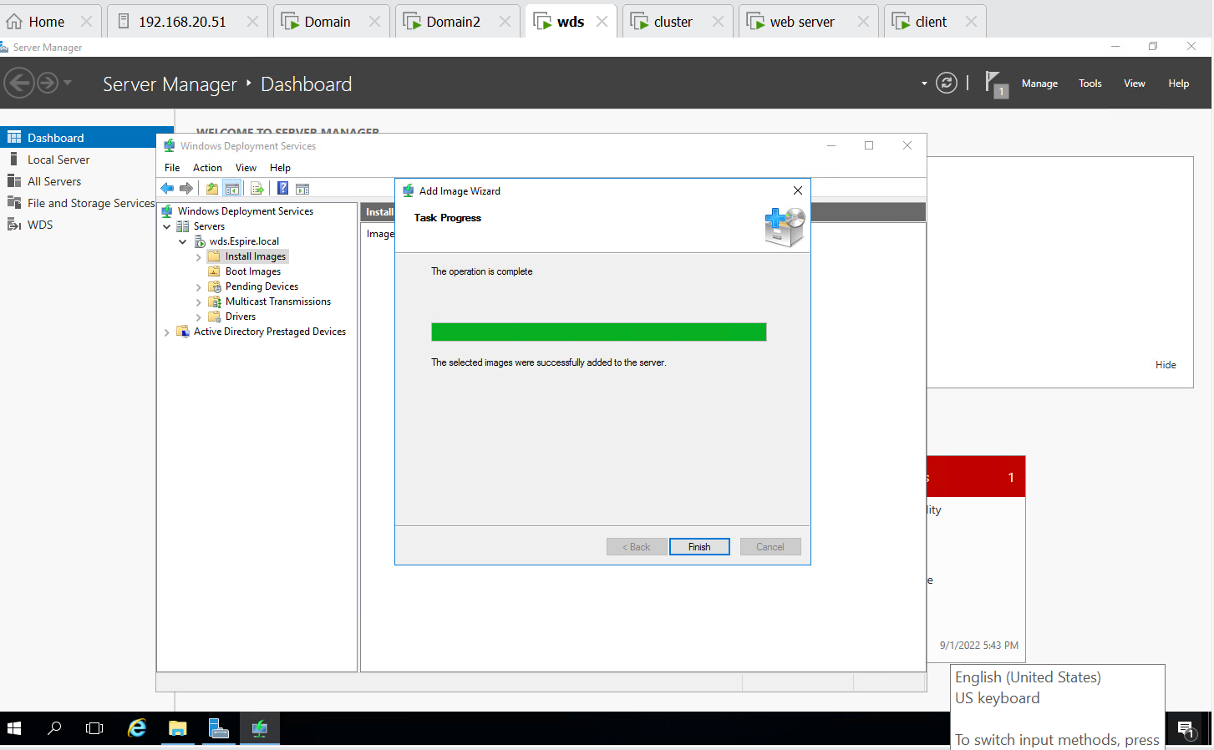

**Step 3:- Fetching CD DRIVE from WDS(192.168.100.3)**

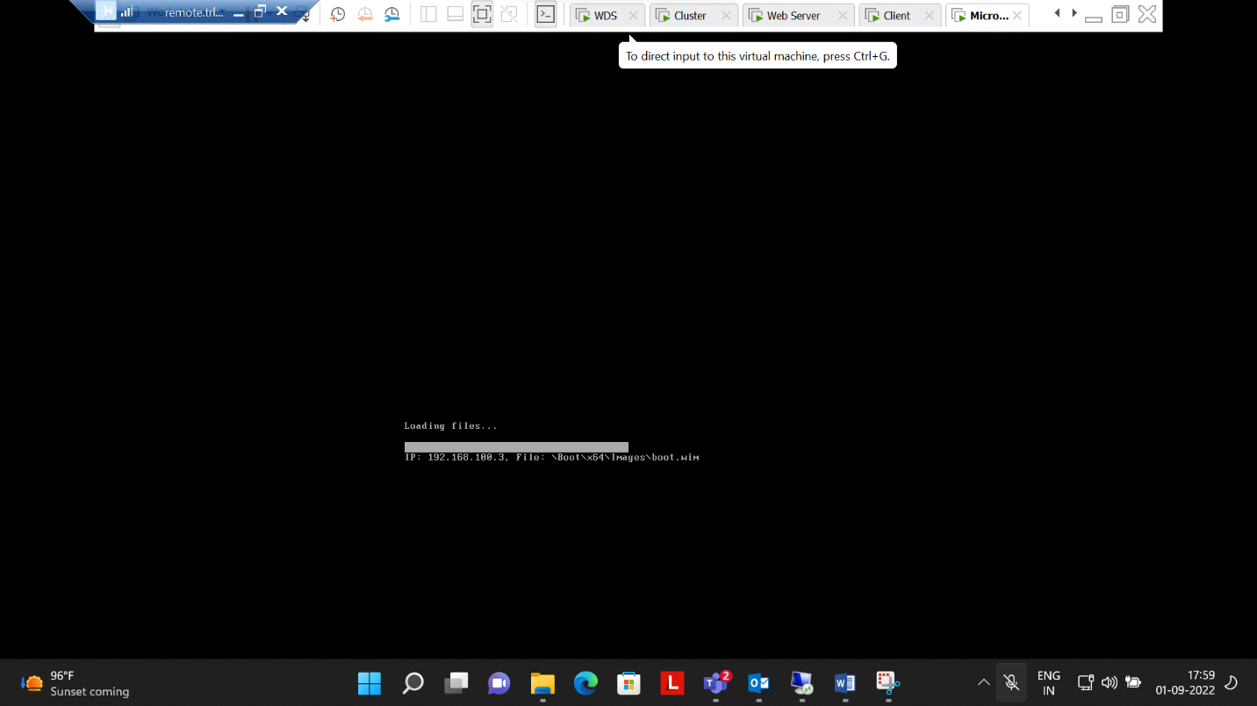

**Step 4:- Successfully operated installation process**

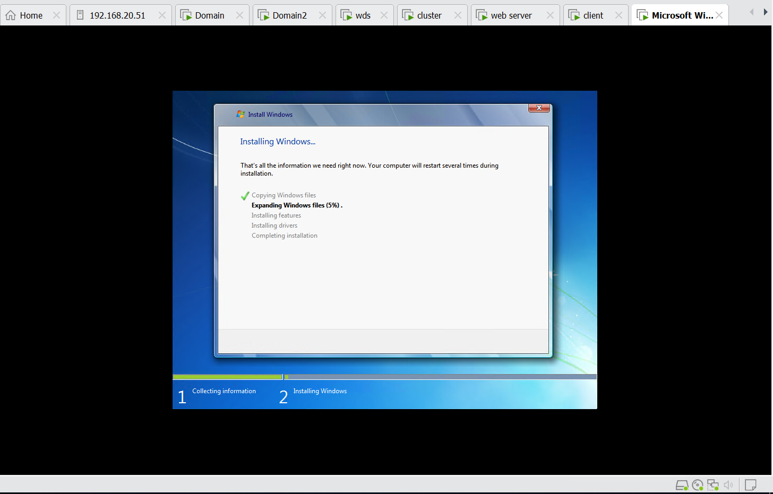

**QUESTION NO. 4 Completed**

1. Transfer all FSMO roles to the ADC using GUI and transfer back to DC using Powershell. Verify if it worked using command line.

**Step 1:- Master Role for RID, PDC, INFRASTRUCTURE change to Domain2 from Domain1**

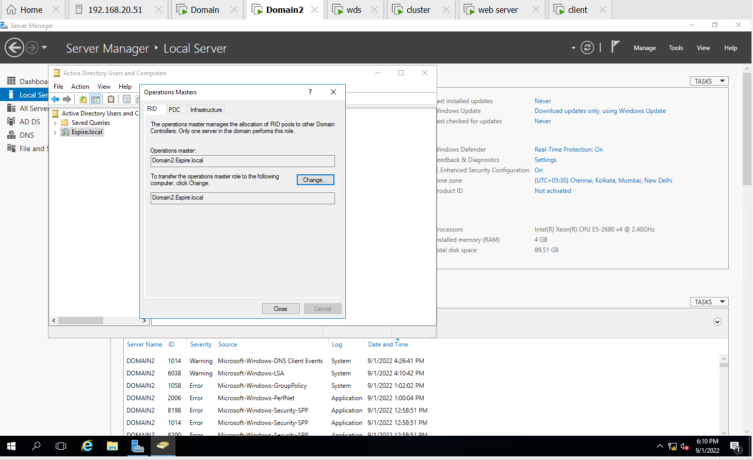

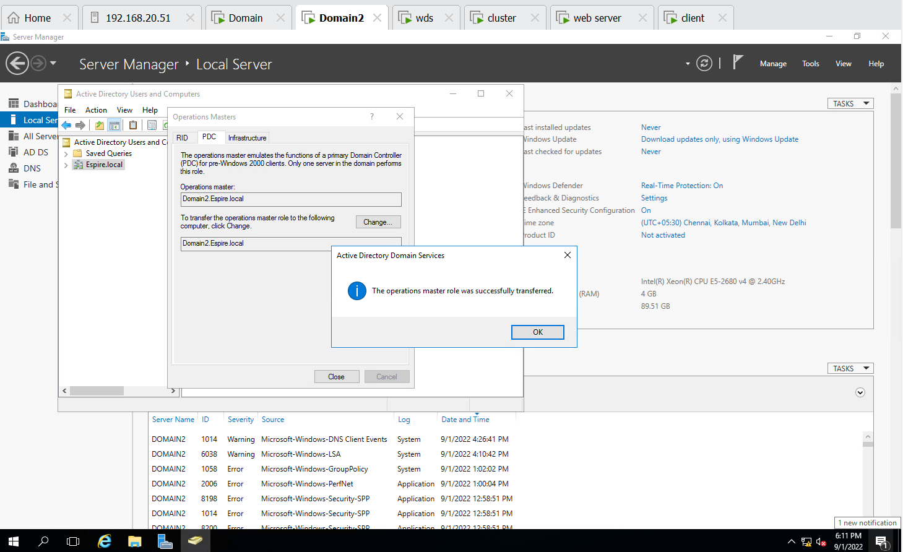

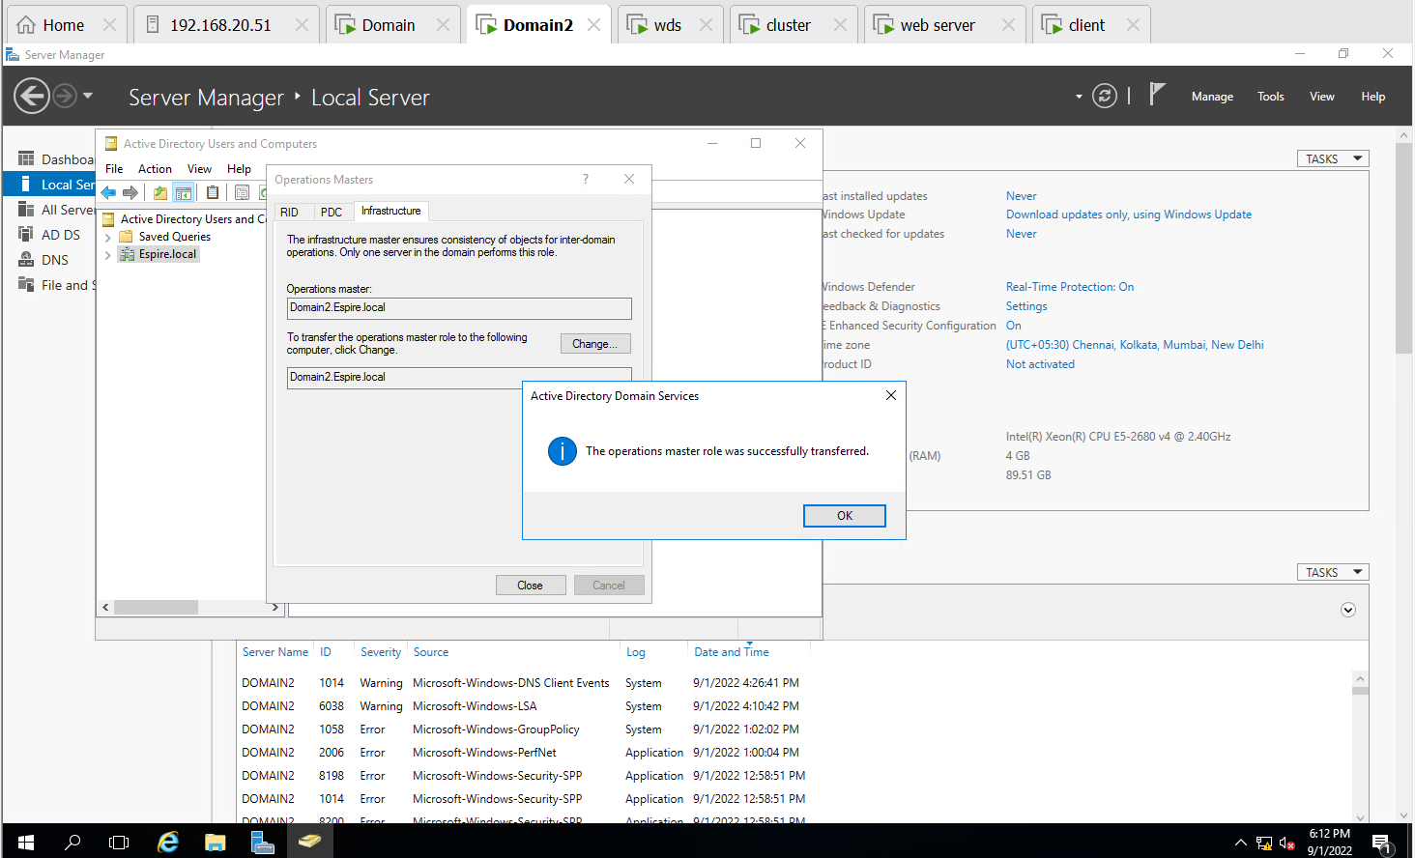

**Step 2:- Changed all controls to domain2 from Domain1**

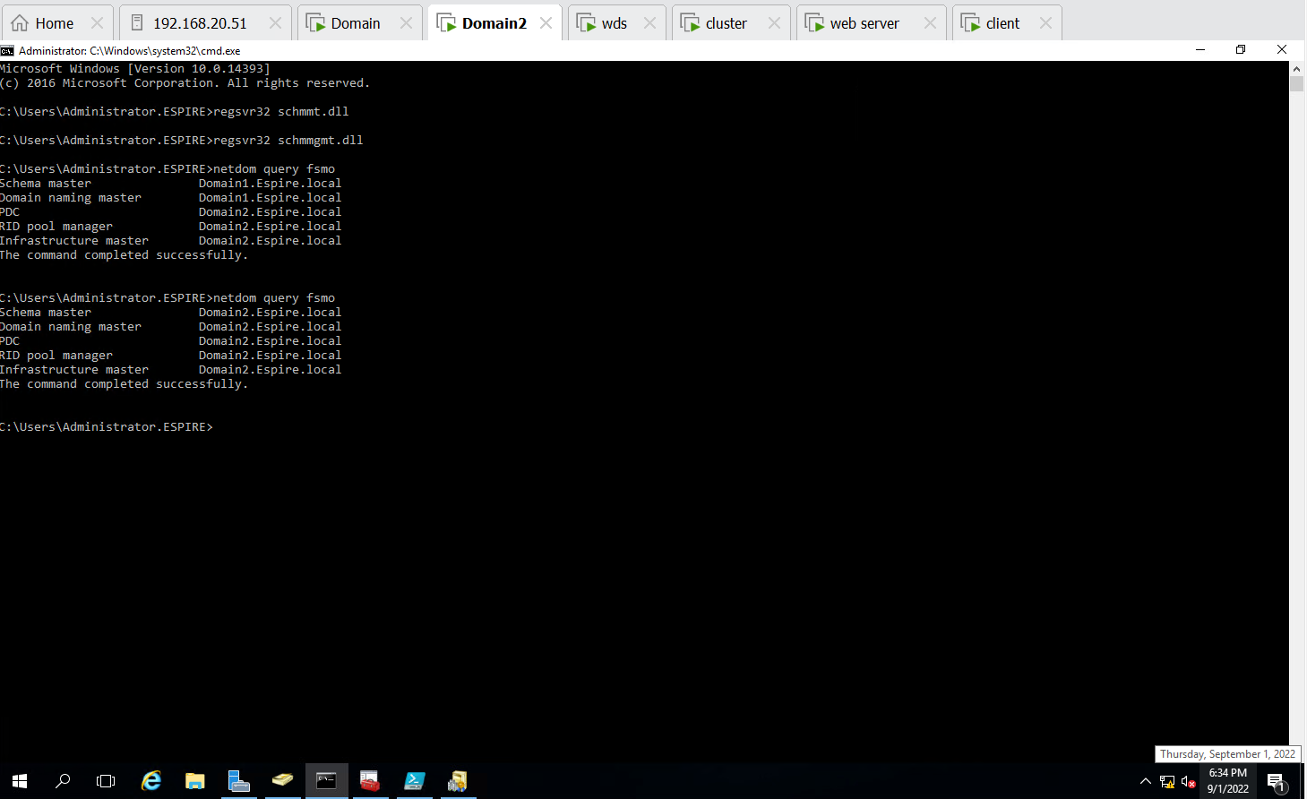

**Step 3:- Implemented Changing controls to Domain1 from domain2 using powershell**

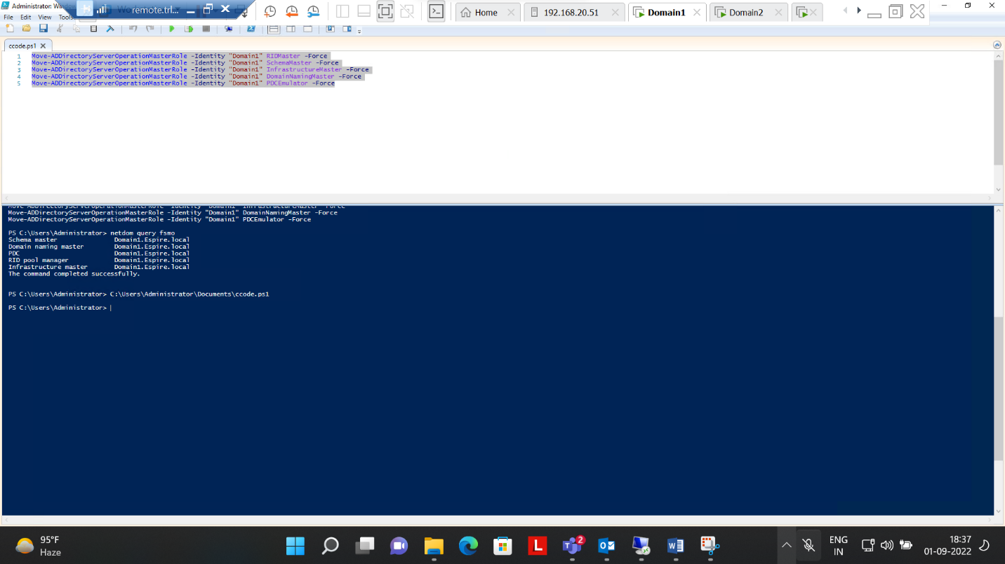

**Step 4 :- Checked all controls changed to Domain1 from Domain2 using CMD**



**QUESTION NO. 5 COMPLETED**

1. Perform installing and Configuring IIS, Create a website with a webpage, Test if it is accessible from the client, protect the Website With SSL

**STEP 1 :- Installed role of Web server IIS in Both Cluster and Web server machine**

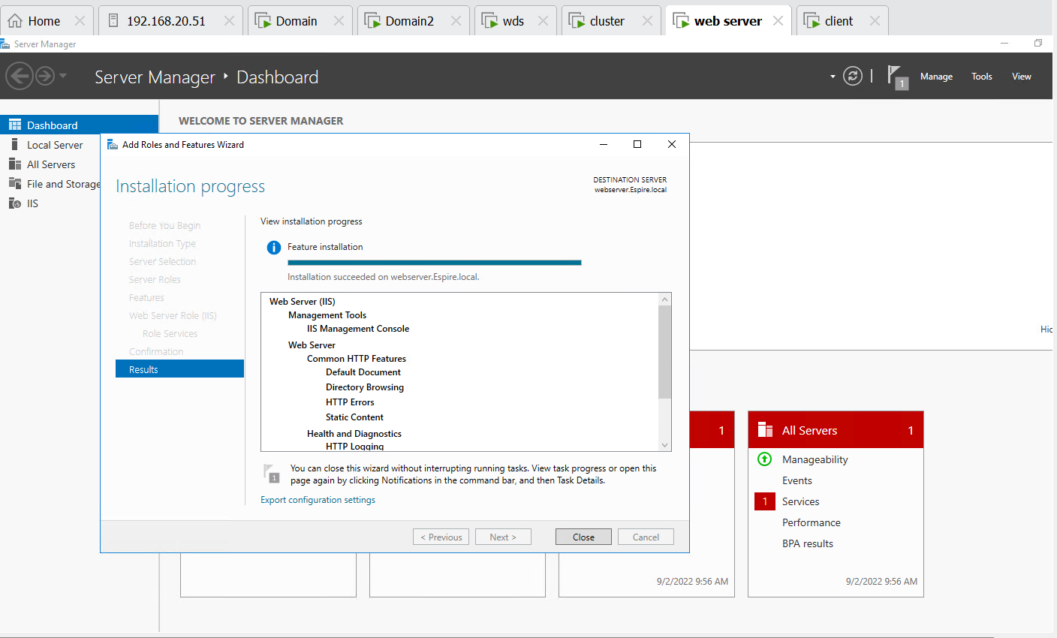

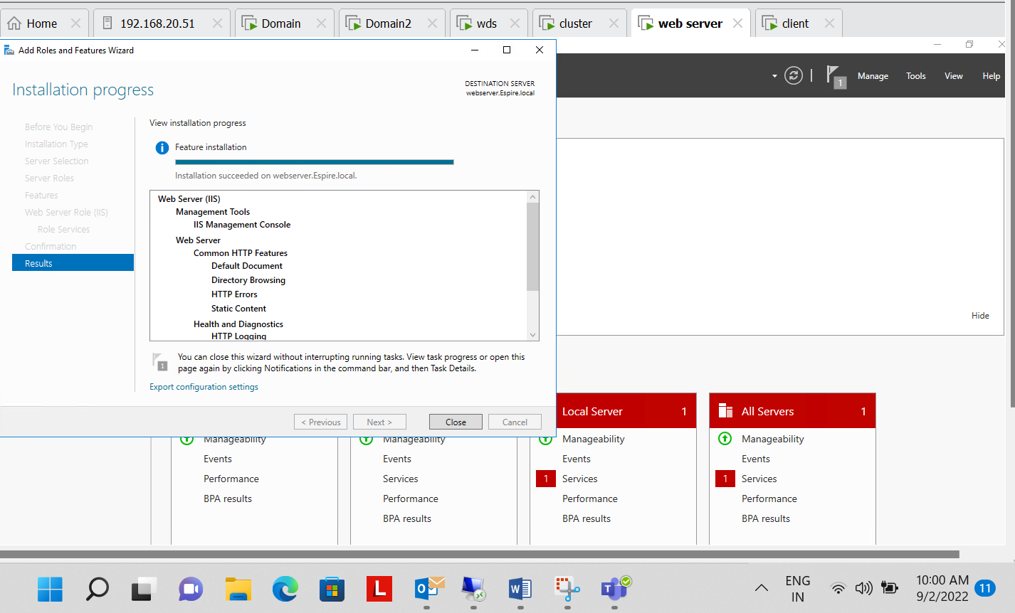

**Step 2:- Installed role of Active Directory Certificate Services on Domain 1**

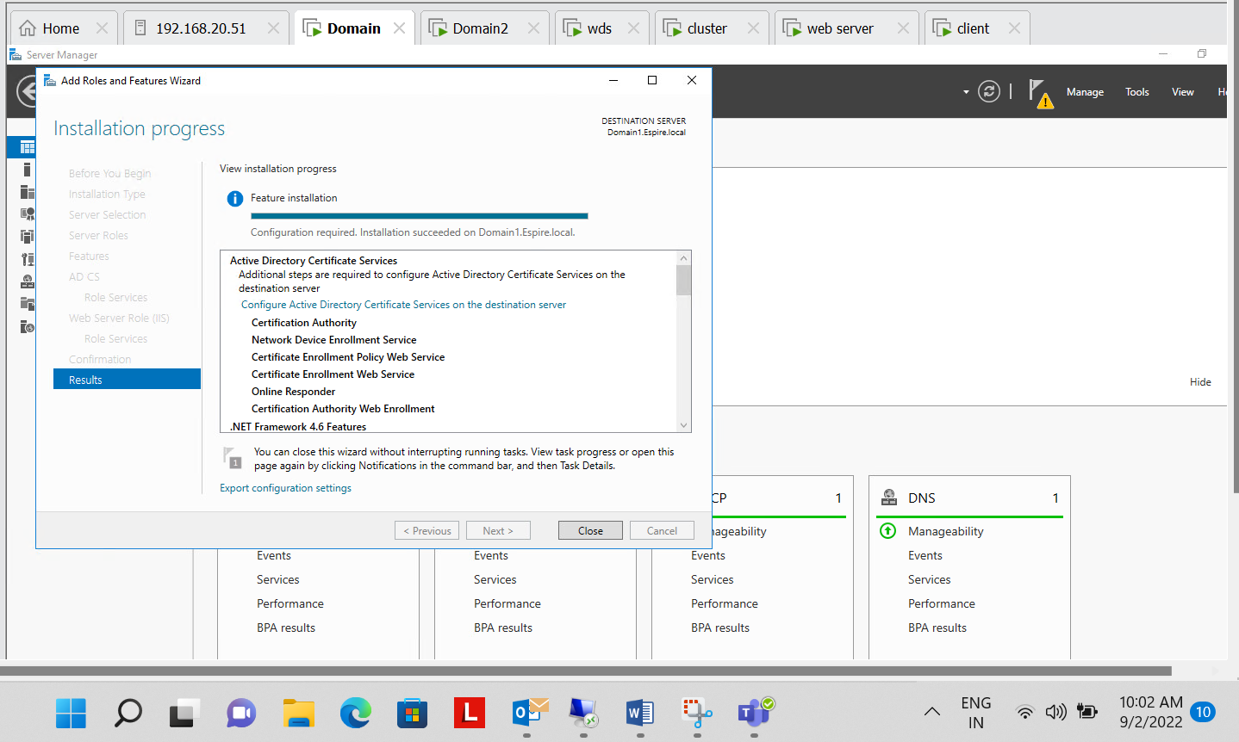

**Step 3 :- Selected Role Services to Configure**

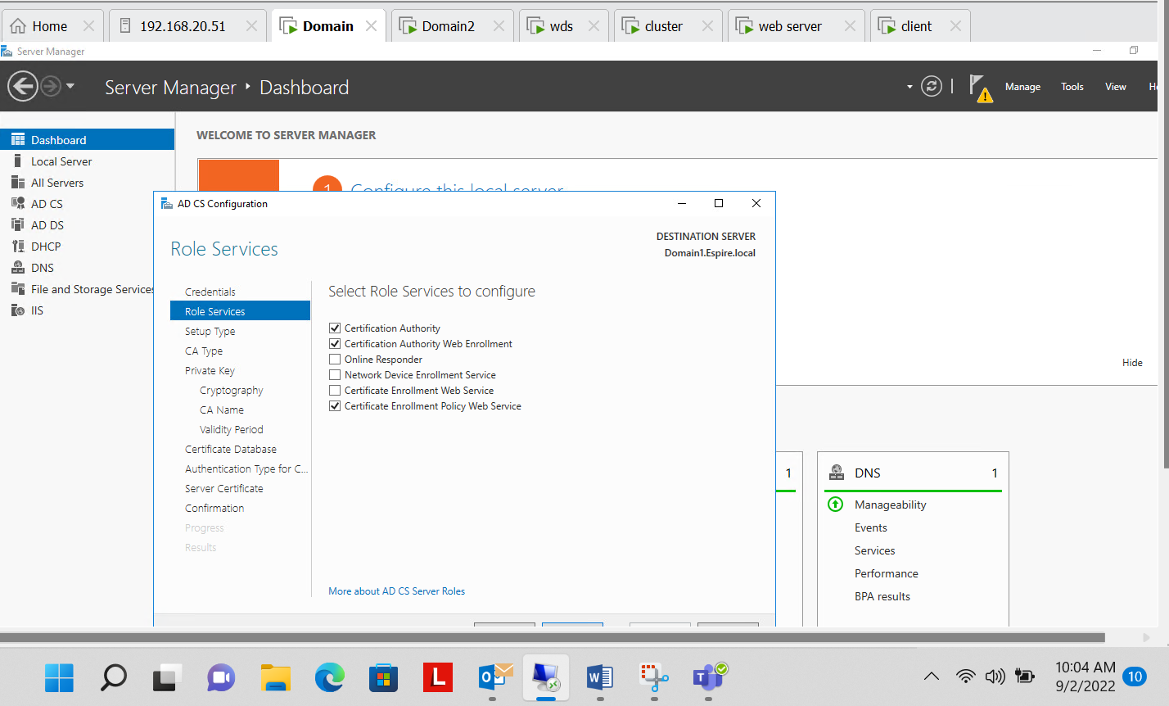

**Step 4 :- Specified the cryptographic options (SHA512)**

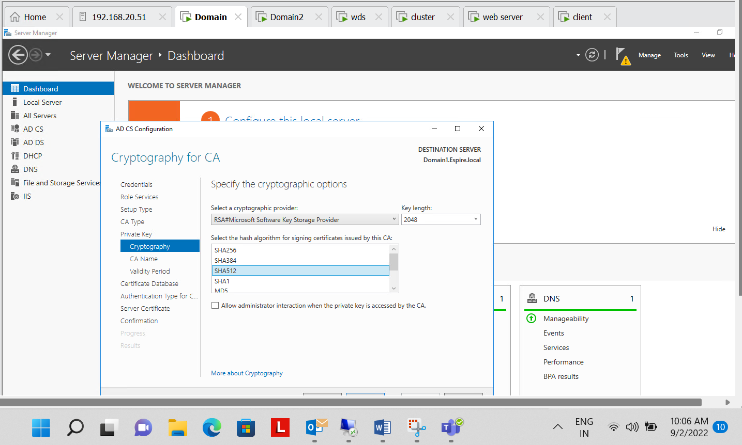

**Step 5:- Configuration Successful od AD CS**

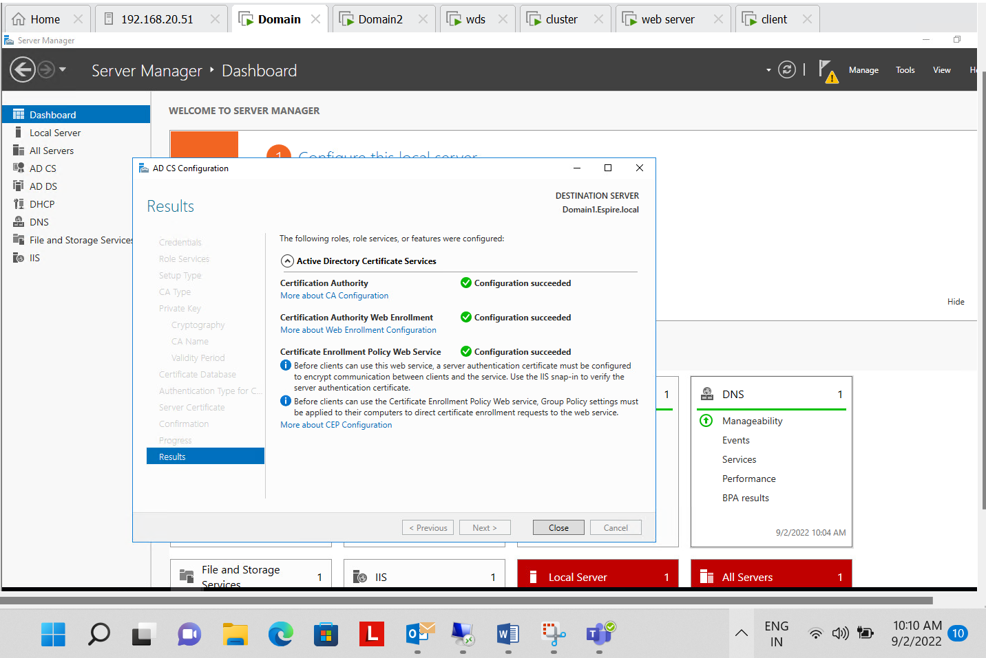

**Step 6:- Online certificate Authority**

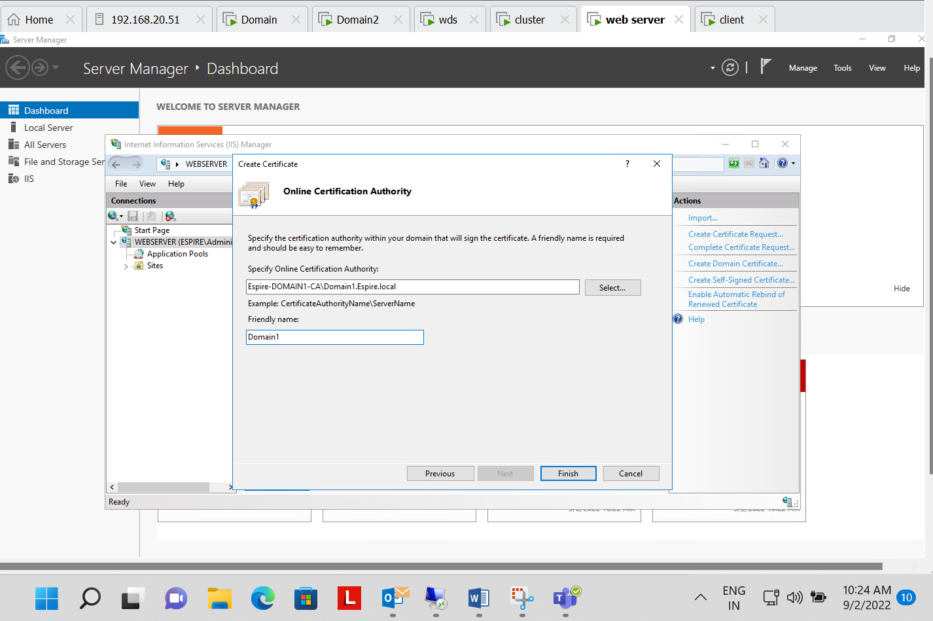

**Step 7:- Certificate issued by Domain1 to Web Server**

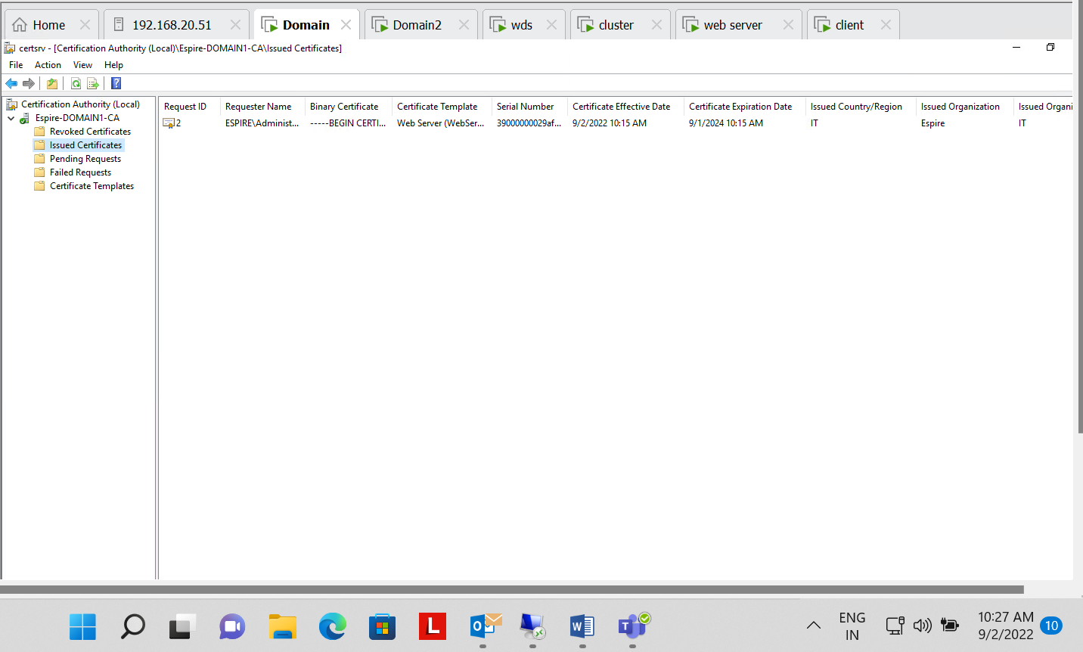

**Step 8:- Binding Done in Web server for https**

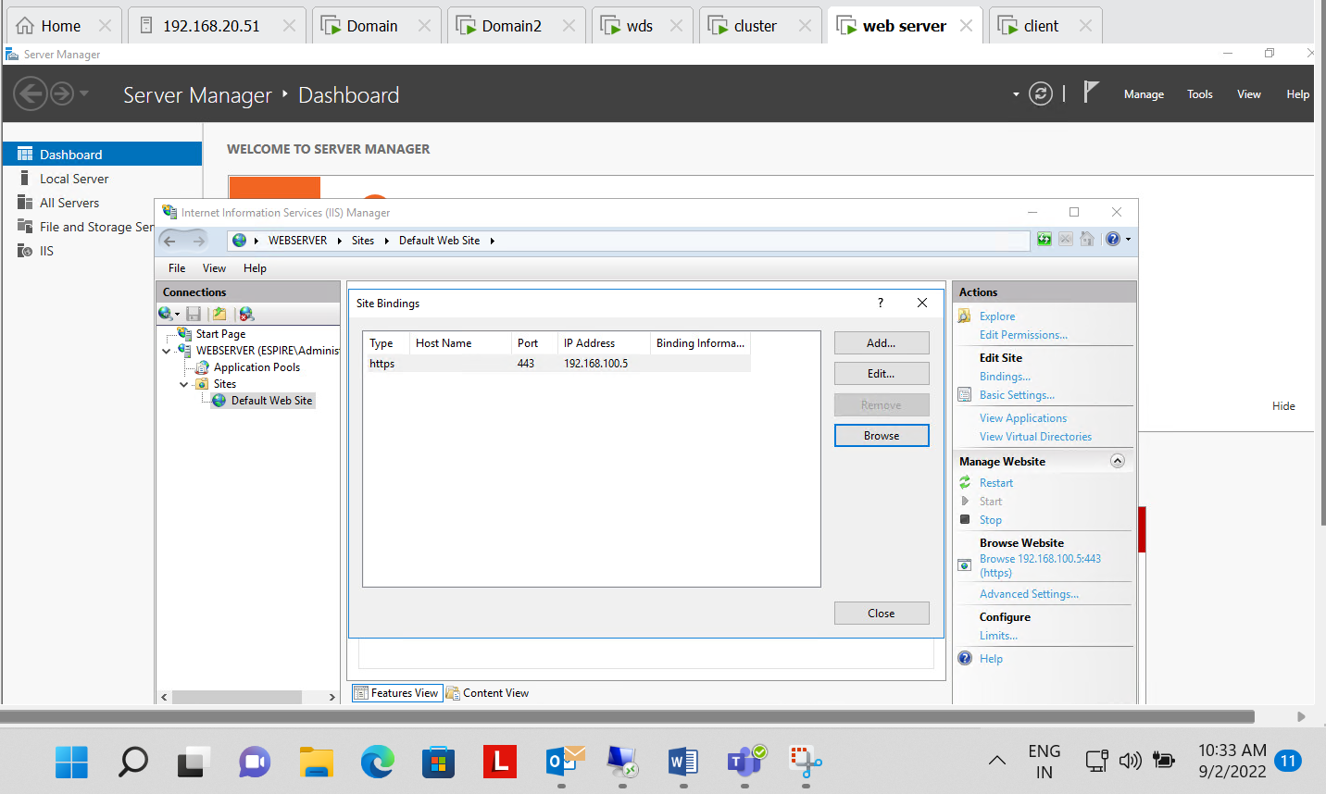

**Step 9:- Successfully checked that web server site can be access from client machine with another user and with https security i.e. (SSL)**

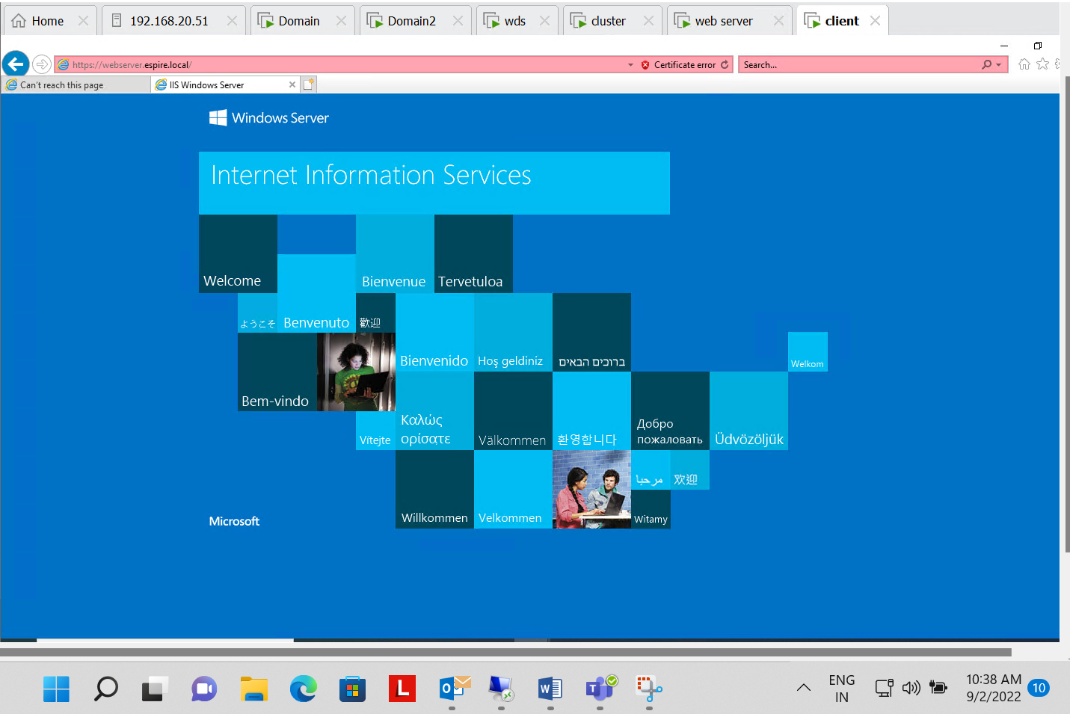

**QUESTION NO. 6 Completed**

1. Perform installing and Configuring Network load balancing features, add two web servers and show the result of load balancing when both the web server is on and if one web server is down

**Step 1:- Installed feature of network load balancing in cluster and webserver**

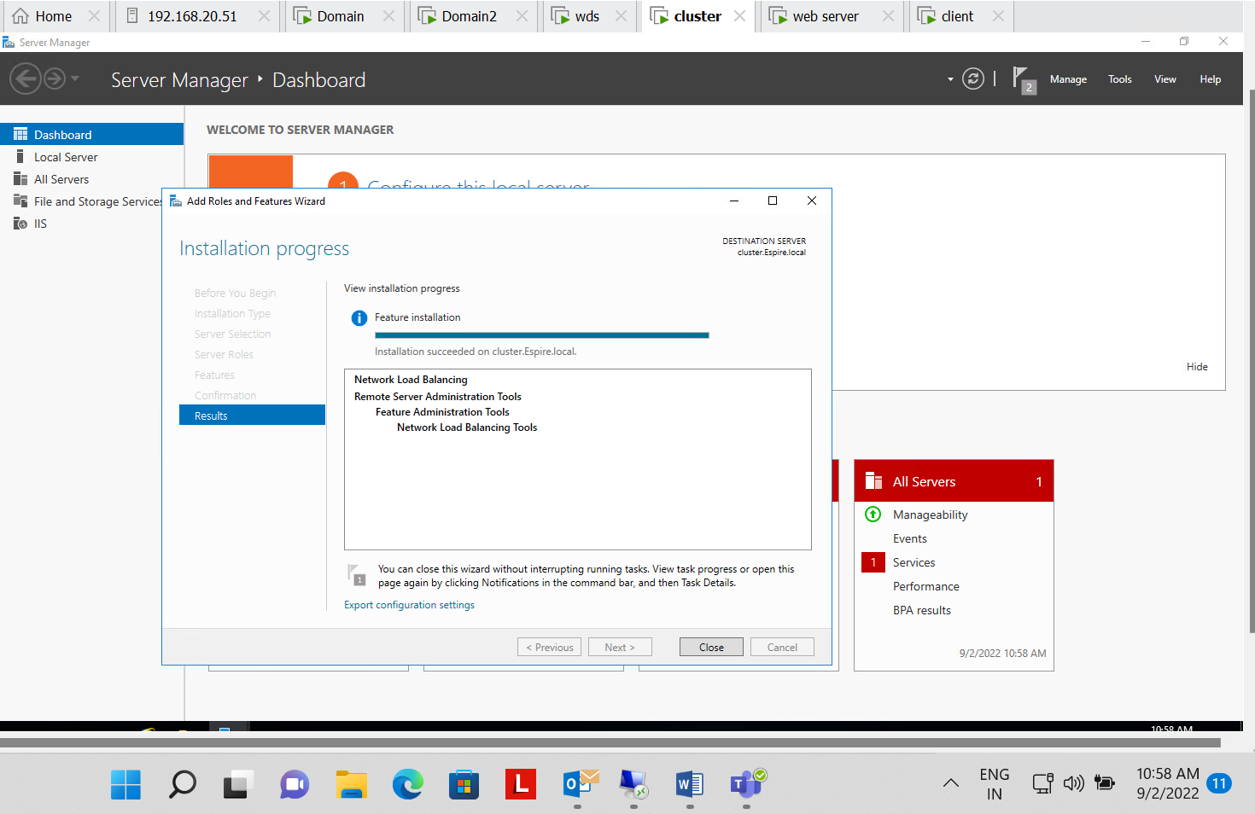

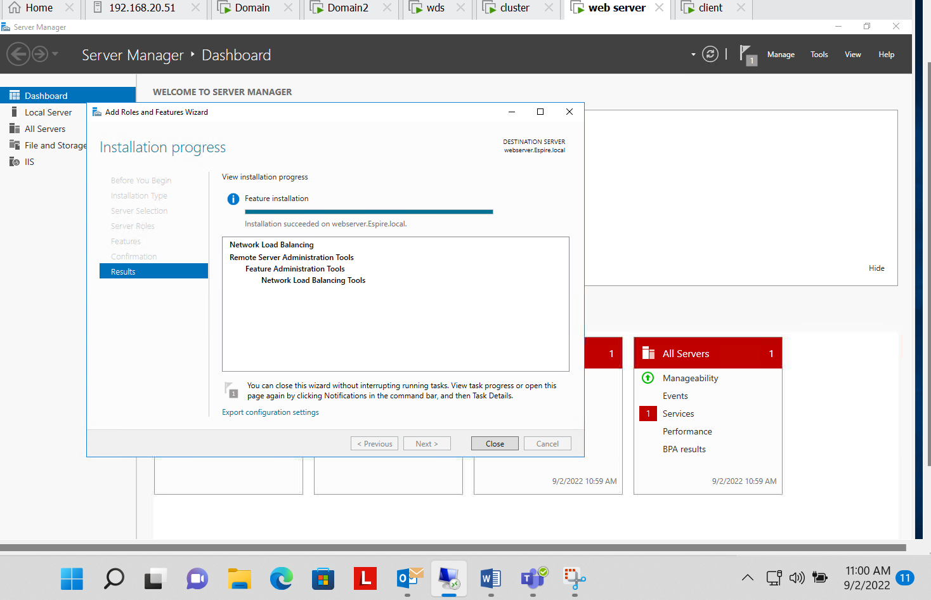

**Step 2 :- Created Host(A) of web server , cluster and nlb(192.168.100.55)**

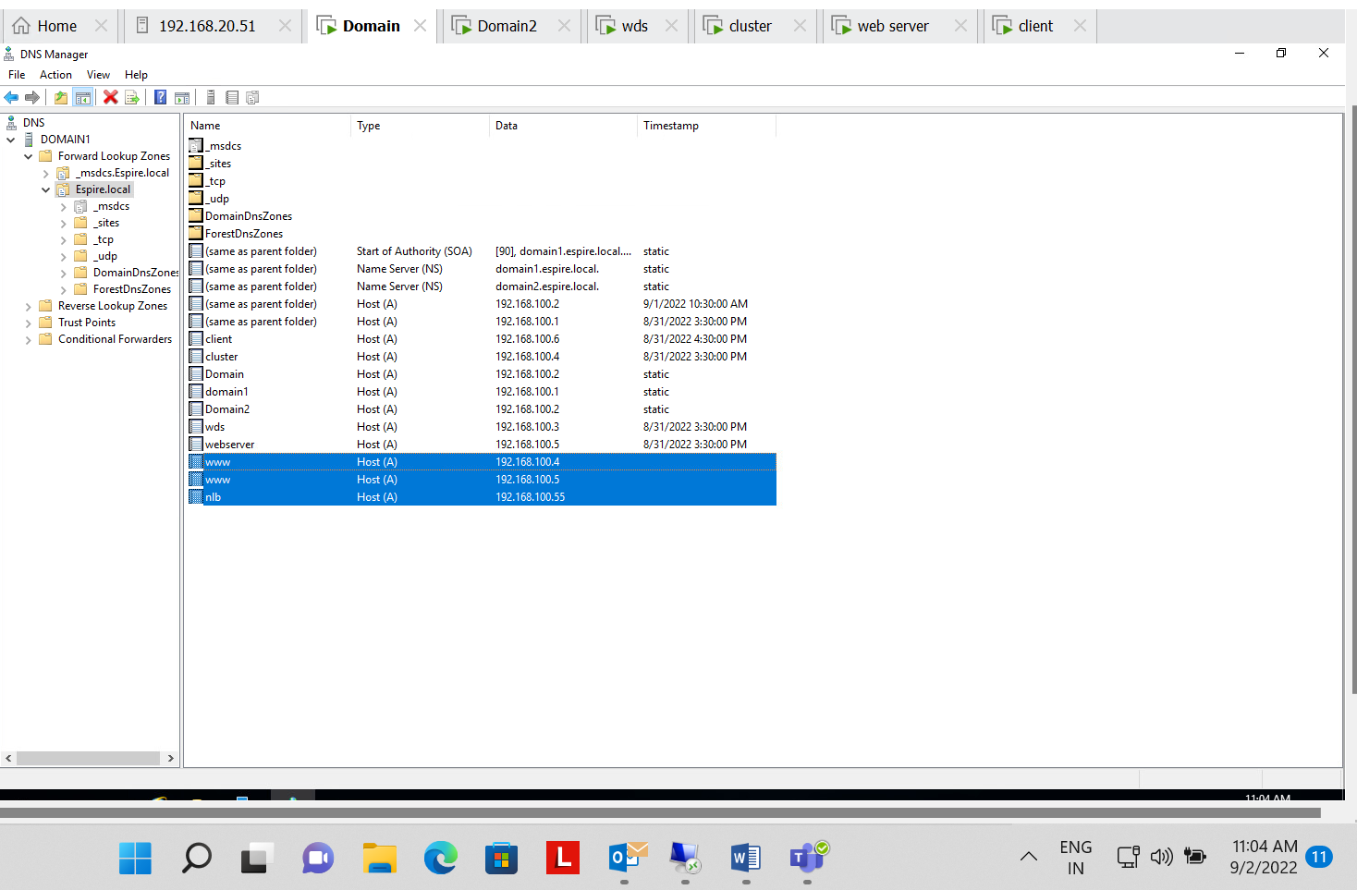

**Step 3 :- Creating new cluster for web server**

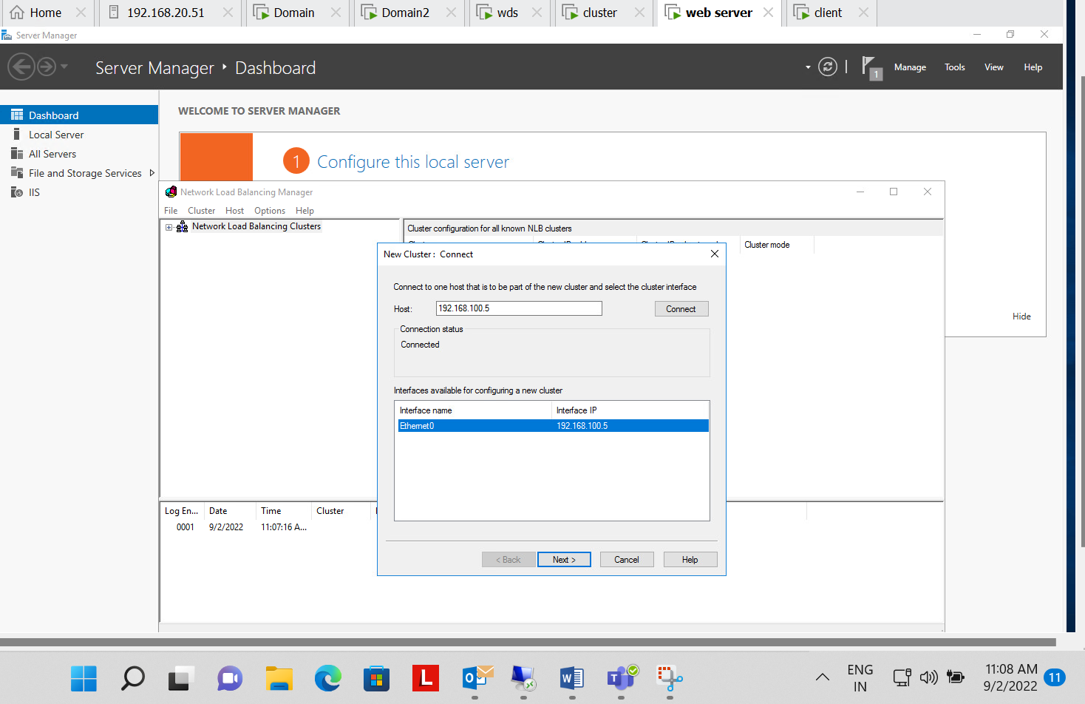

**Step 4:- Added the cluster ip address (nlb)**

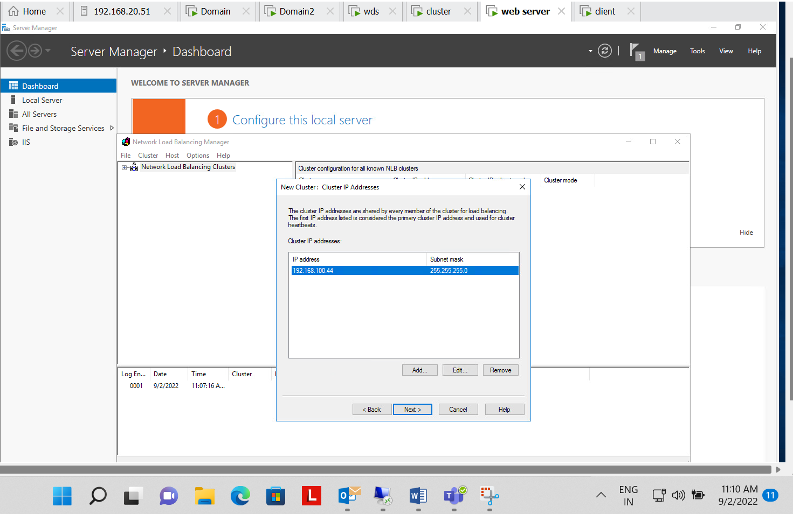

**Step 5 :- Cluster parameter**

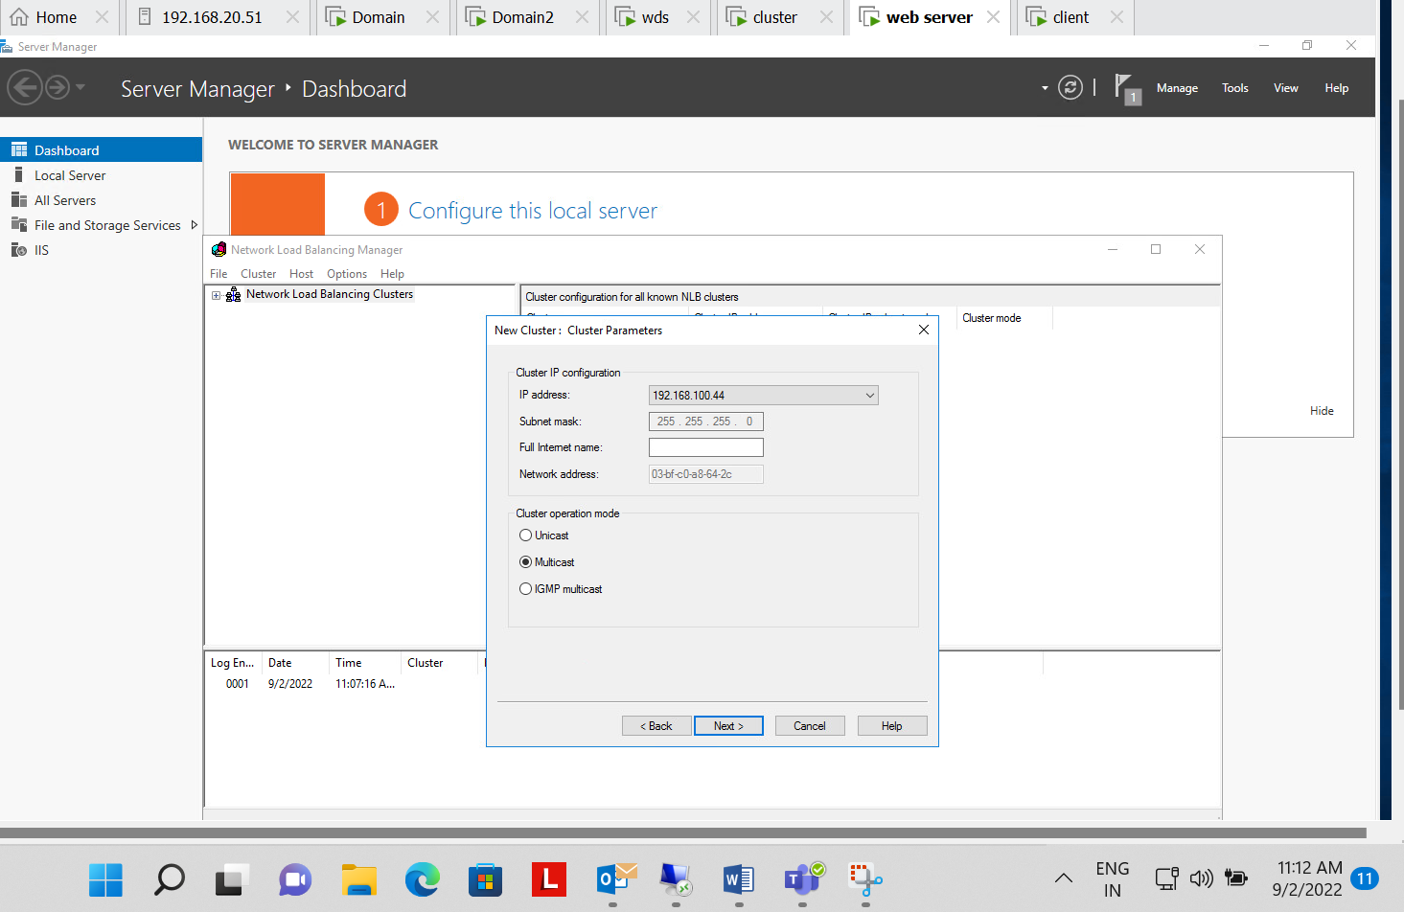

**Step 6 :- Both the machines i.e. cluster and webserver are connected with 192.168.100.55(nlb)**

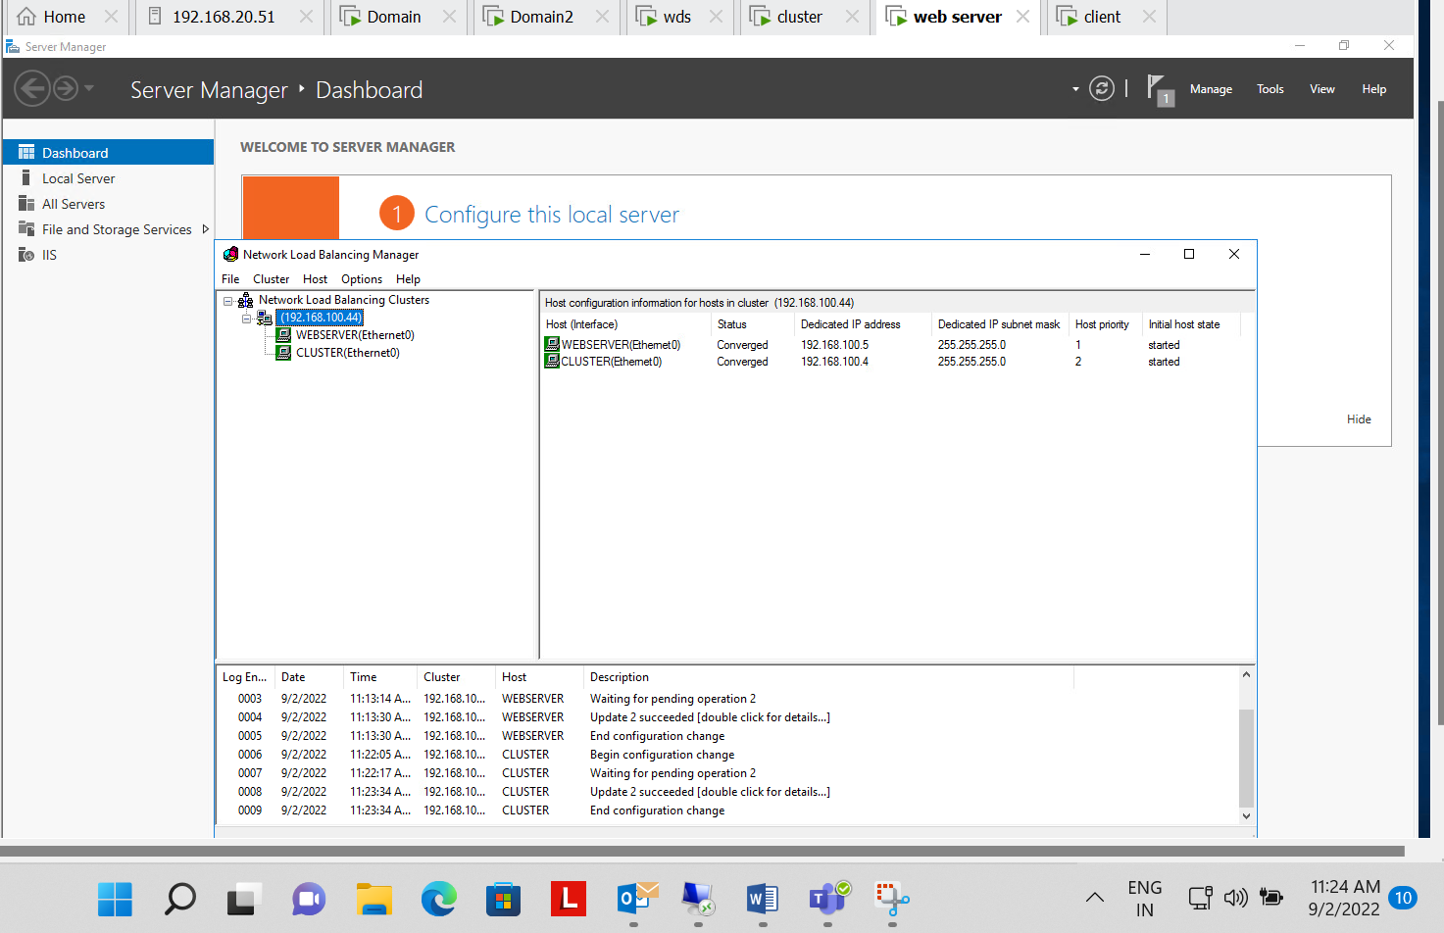

**Step 7:- Cluster(192.168.100.4) can be accessed through client**

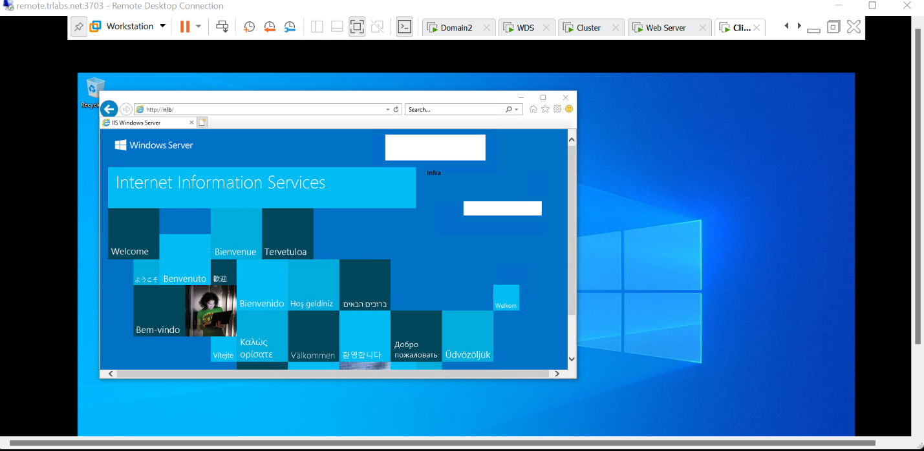

**Step 8 :- Webserver(192.168.100.5) Can be accessed through client machine after suspending cluster(192.168.100.4)**

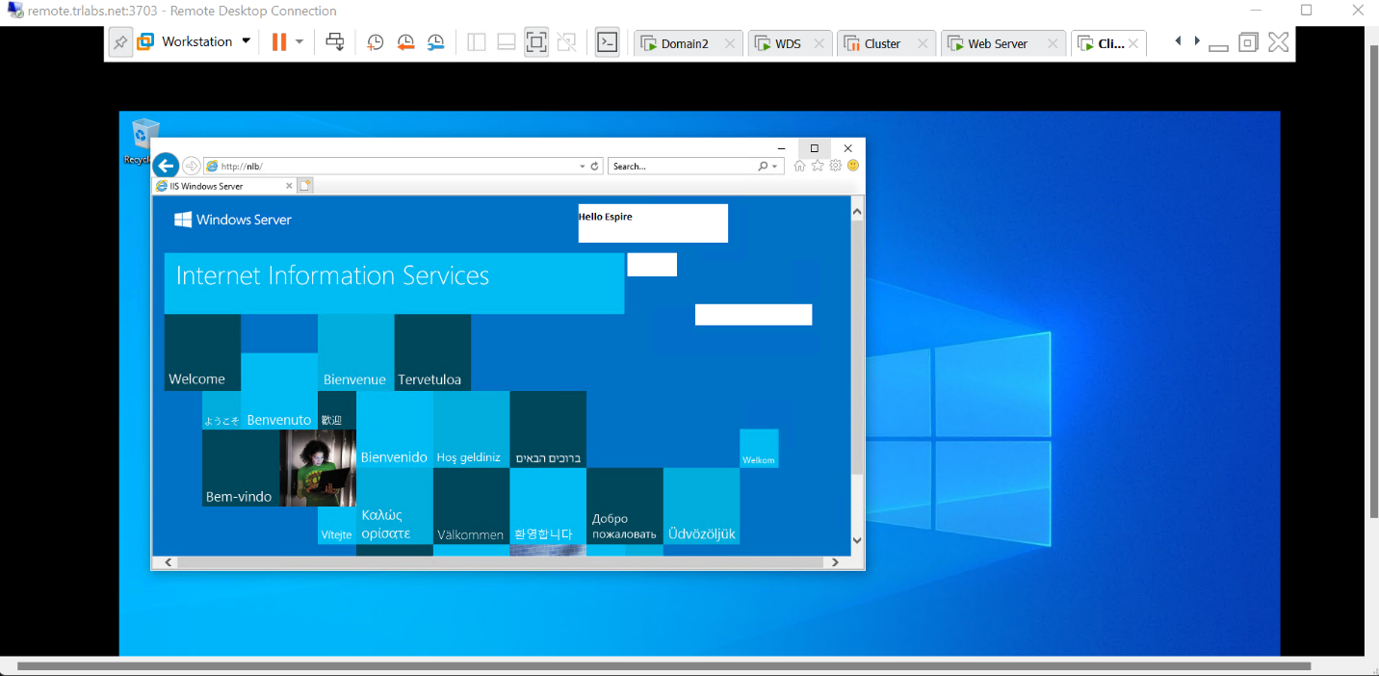

**QUESTION NO. 7 COMPLETED**

1. Implement ADC Replication. Verify if it is working

**Step 1:- Created new site(UP)**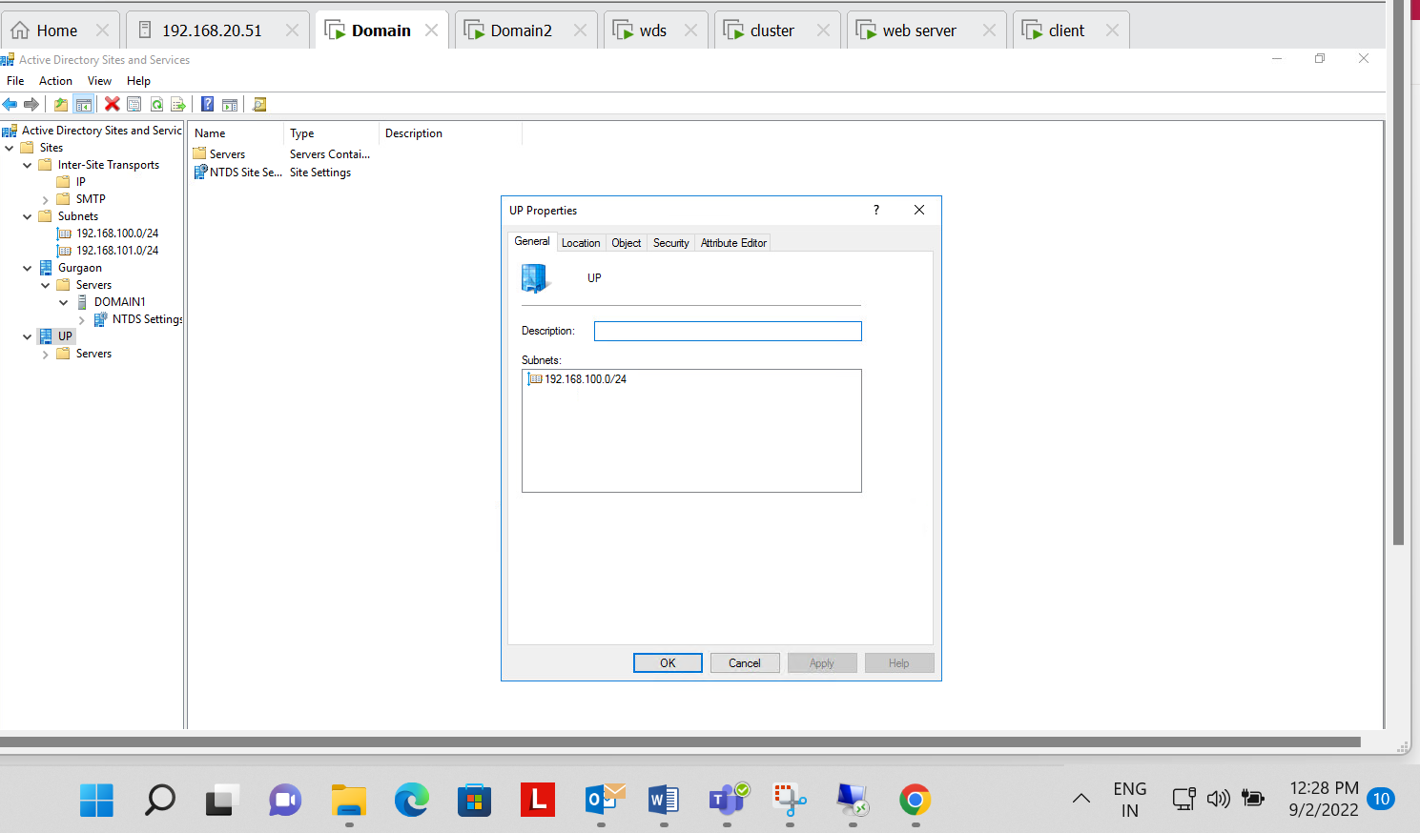

**Step 2 :- Created both Subnets for (UP & Gurgaon)**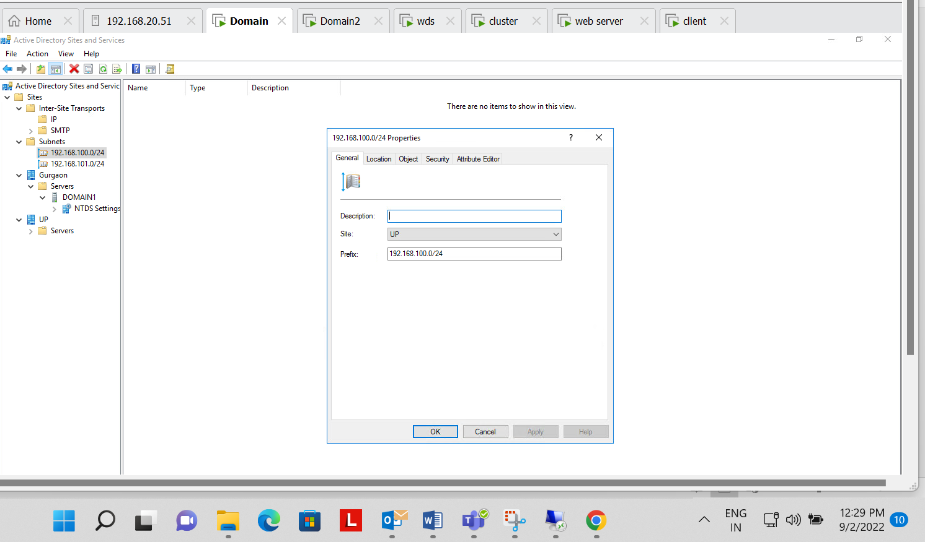

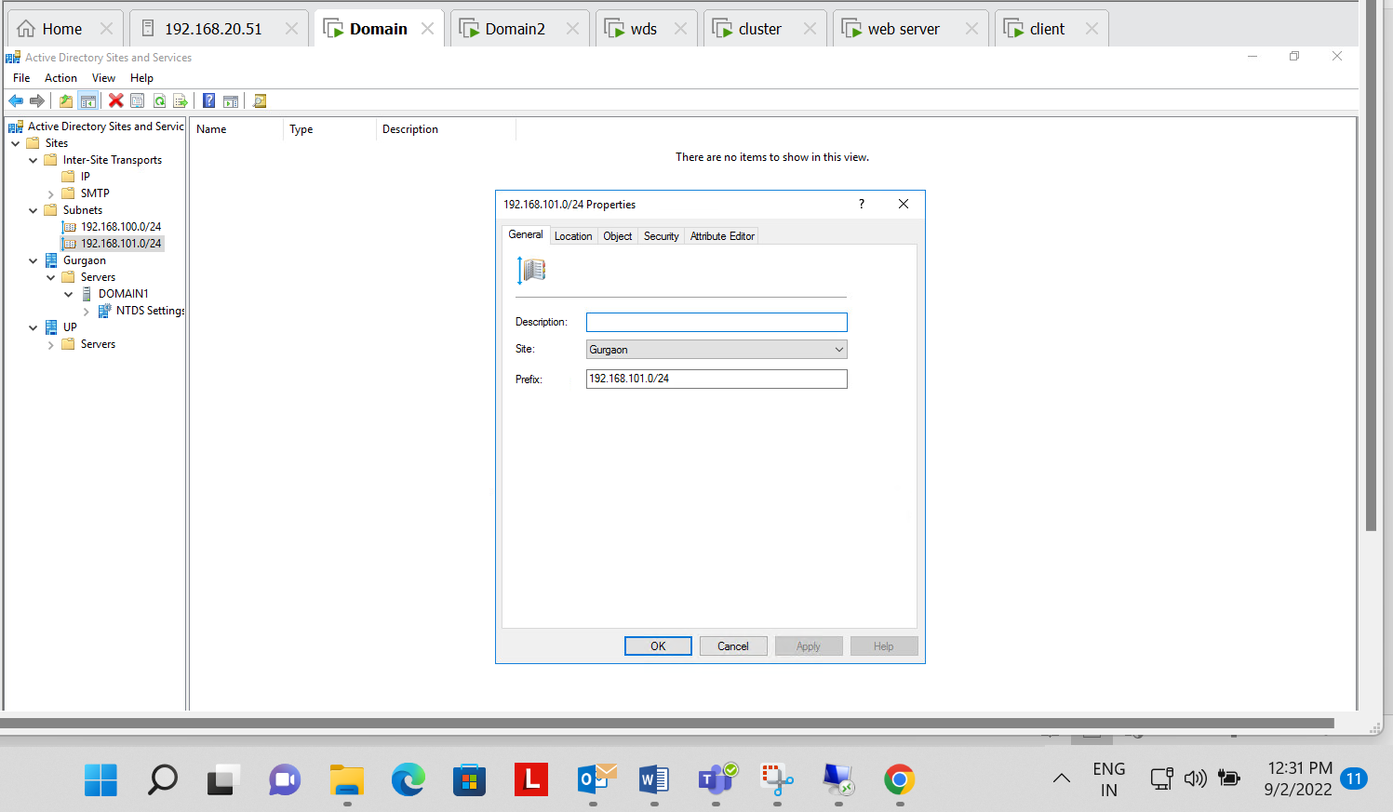

**Step 3 :- Replication not available in working hours**

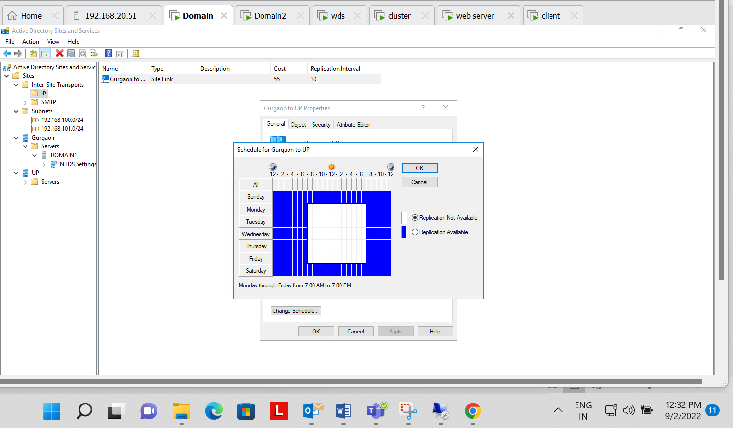

**Step 4 :- All the process are done and now its working**

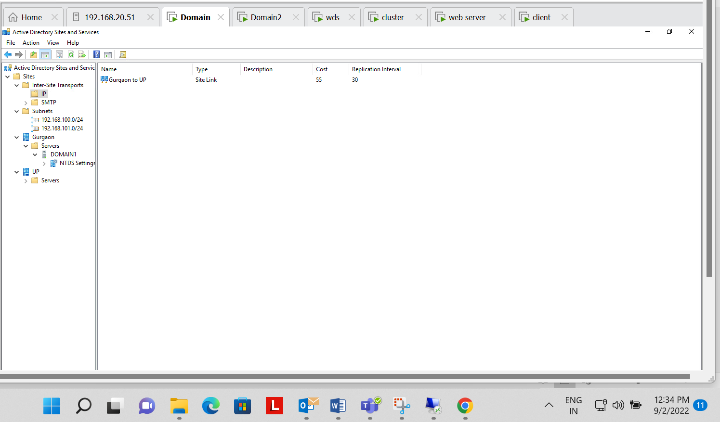

**Question Number 8 Successfully Completed**

**ALL QUESTIONS ARE COMPLETED**